Decisions on Buffer Logic for the Simio Shelving Shop

Simulation Model, Experiment, Design, and Results (Final Report)

Presented to:

Dr. Suresh Khator

University of Houston

In Partial Fulfillment of  
the requirements for the course:  
INDE-6370 Operations Research & Digital Simulation

Prepared by:

Umme Ammara & Isaiah Gerald  
May 2021

**Table of Contents**

1. INTRODUCTION --------------------------------------------------------------------------------------------- 2
   1. System Review & Theory ----------------------------------------------------------------------- 2
   2. Modeling Approach ------------------------------------------------------------------------------ 2
   3. Model Process Flow Diagrams ----------------------------------------------------------------- 3
   4. Model Overview & Process Logic ------------------------------------------------------------- 5
2. BACKGROUND ----------------------------------------------------------------------------------------------- 15
   1. Assumptions --------------------------------------------------------------------------------------- 15
   2. Problem Background ----------------------------------------------------------------------------- 15
   3. Strategies for Consideration --------------------------------------------------------------------- 15
3. DATA ANALYSIS -------------------------------------------------------------------------------------------- 17
   1. Initial Findings ------------------------------------------------------------------------------------ 17
   2. Input Analysis & Distribution Fitting ---------------------------------------------------------- 18
   3. Trends & Key Information ----------------------------------------------------------------------20
   4. Model Verification & Validation --------------------------------------------------------------- 22
4. MODIFICATIONS -------------------------------------------------------------------------------------------- 24
   1. DDMRP Overview ------------------------------------------------------------------------------- 24
   2. Process Structural Changes --------------------------------------------------------------------- 25
5. DESIGN OF EXPERIMENTS ------------------------------------------------------------------------------ 28
   1. Selection of Key Responses -------------------------------------------------------------------- 28
   2. Experiment Controls ----------------------------------------------------------------------------- 28
6. CONCLUSION ------------------------------------------------------------------------------------------------ 29
   1. Simulation Runs & Results --------------------------------------------------------------------- 29
   2. Recommendations -------------------------------------------------------------------------------- 29
7. INPUT ANALYSIS -------------------------------------------------------------------------------------------- 31
   1. Order Arrival Distribution Fitting -------------------------------------------------------------- 31
   2. Percent Defective Units Distribution Fitting -------------------------------------------------- 34
   3. Supplier Lead Time Distribution Fitting ------------------------------------------------------ 37
   4. Station Processing Time Distribution Fitting ------------------------------------------------- 41
   5. Material Inspection Time Distribution Fitting ------------------------------------------------ 47
   6. Distribution Fitting Result for all Categories ------------------------------------------------- 52

# 

# 1.INTRODUCTION

## 1.1 System Review & Theory

The Simio Shelving Shop is a cellular manufacturing process that consists of four manufacturing cells including, a shelf assembly cell, a frame assembly cell, a back-panel cell, and a cell used for final assembly of each kind of shelf. Each cell has several designated stages which in turn are made up of individual stations operated by one of 33 employees. Components produced at the first three cells are fed to the final assembly cell where they are combined into completed shelving units. This process can produce up to six different variants of shelf and make up the core of an entire business model.

Being tasked with carrying out a complete analysis of this system to identify and resolve key problems that have been experienced during normal operation, we developed a steady-state simulation model to reflect the process data provided and be able to examine the long term characteristics of the system. Since the demand for these shelves comes from an external source and can be unpredictable at times, we chose to create a stochastic load for this model. This was done through input analysis which was also conducted on other key areas where variation was in the process data including the lead time for raw materials, percent of defective materials received from suppliers, and the processing time for different stations as well. The final construct we used to build our model was a dynamically changing environment where time plays a large role as queue build, materials run out and workers go home to their families.

Applying these constructs through Simio Simulation Software we were able to build an intricate model that captured all the nuances of the real-life system. This was crucial in the development of simulation experiments, the identification of key variables, and the selection of an optimal solution. Following the outline set by this modeling concept we went on to analyze the system over replications utilizing mathematical optimization techniques, in addition to probabilistic and statistical methods.

## 1.2 Modeling Approach

To construct a fully working model that correctly represented the system we started from the top down by breaking the model down into its fundamental components. These considered the two external factors that influenced the process with the shop at its center. Starting with the supply of raw materials as the backend, the shelf construction process and the core, and the interaction with end customers as the frontend, we separate each part of the system into a hierarchical framework. Conceptually, this was three independent systems each consisting of four major areas that connected with one another in a linear fashion but, in practice they each communicated through multiple channels to make the entire system work. The components that made up this high-level model are seen in the figure on the following page.

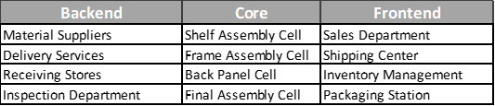

Figure 1: Modeling Approach

By separating the initial system into three unique classes and then further into functional areas we easily connected departments by their respective inputs and outputs. Connecting these subcomponents, we were able to determine the critical path for individual parts and lay down the necessary objects in Simio. The resulting block diagram shown below also acted as a road map for how to route resources, materials, and entities as we built the model.

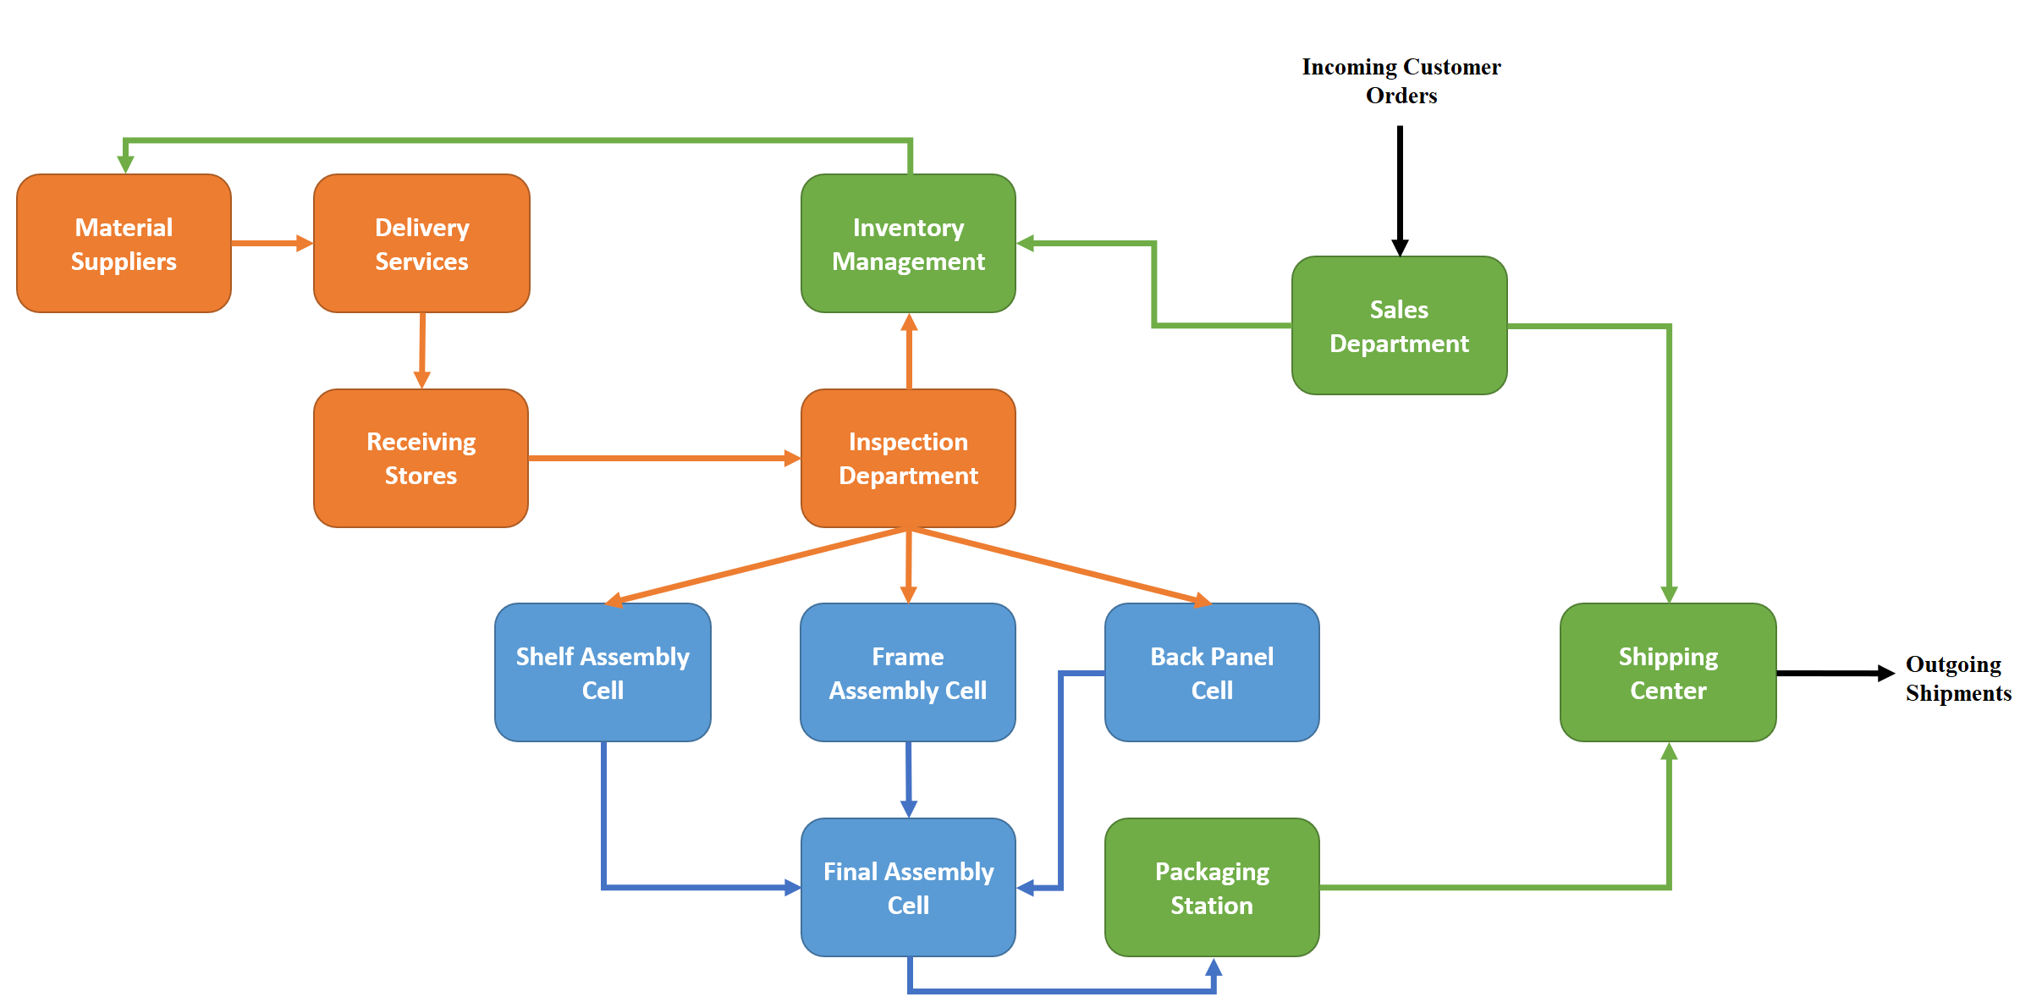

Figure 2: Model Block Flow Diagram

## 1.3 Model Process Flow Diagrams

From the block flow diagram, we initiated our model development with the following skeleton flow diagram. Details for each section are displayed on the following pages.

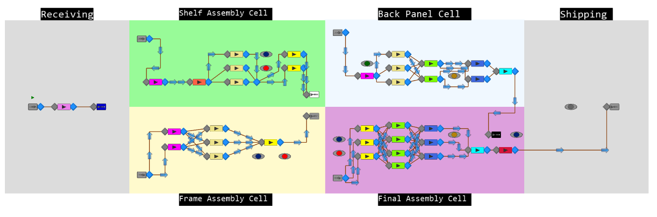

Figure 3: Model Process Flow Basic Layout

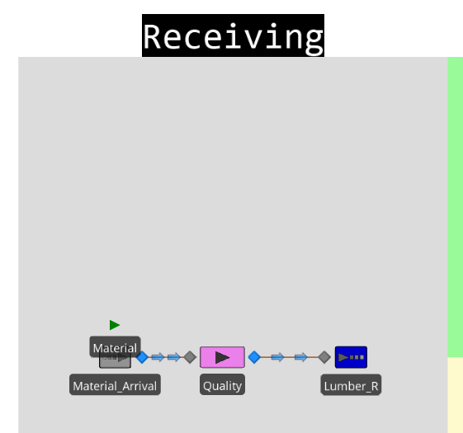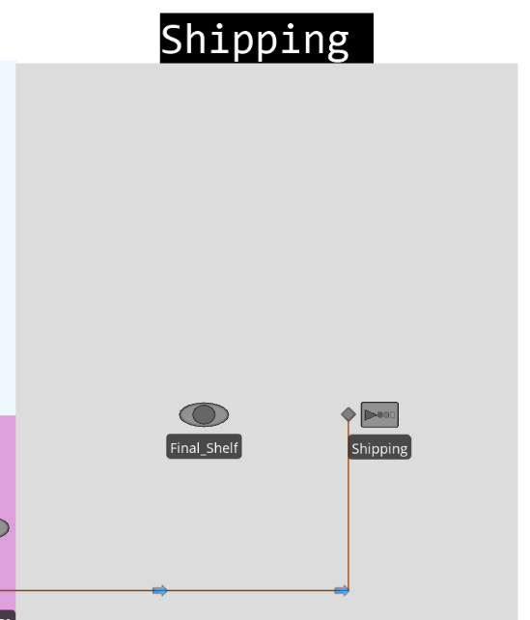

Figure 4: Overview of Workflow for Receiving and Shipping

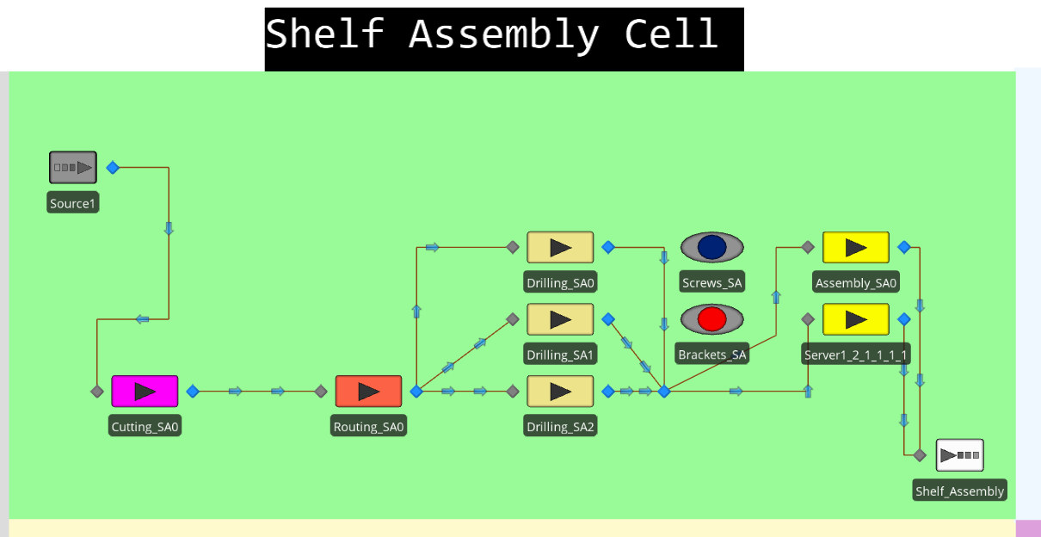

Figure 5: Overview of Workflow for the Shelf Assembly Cell

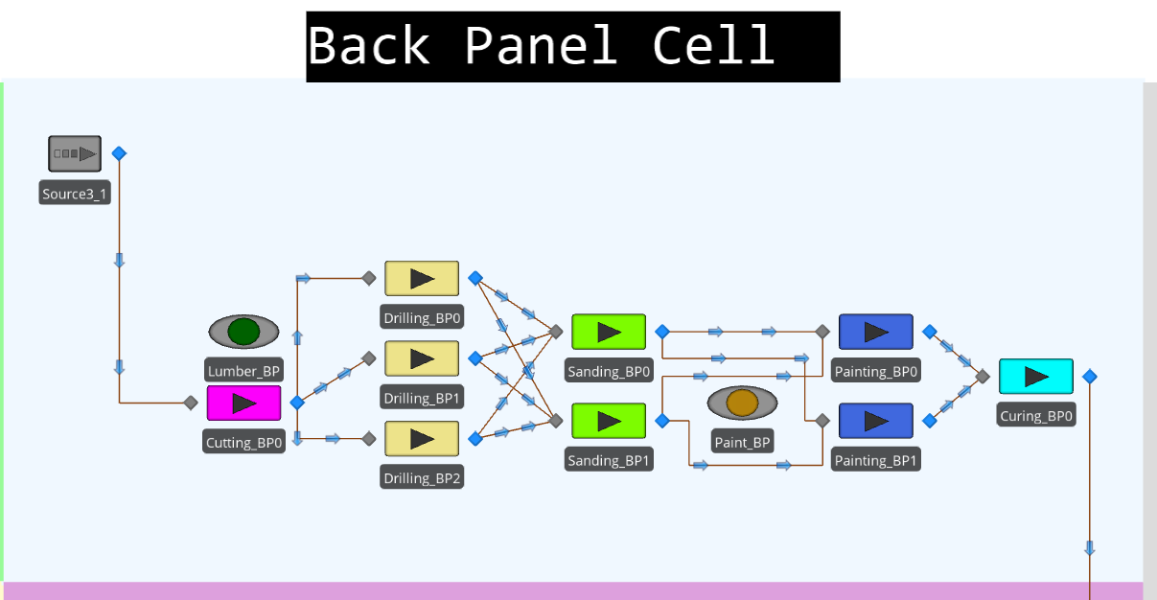

Figure 6: Overview of Workflow for the Back-Panel Cell

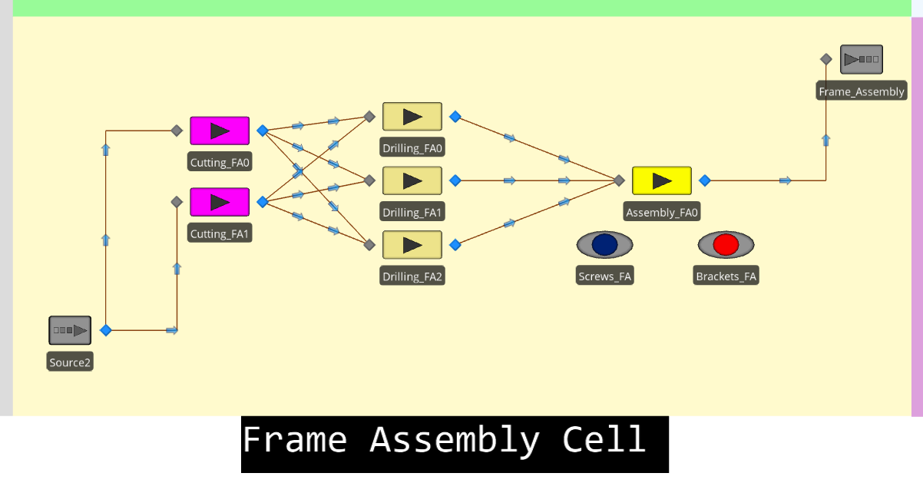

Figure 7: Overview of Workflow for the Frame Assembly Cell

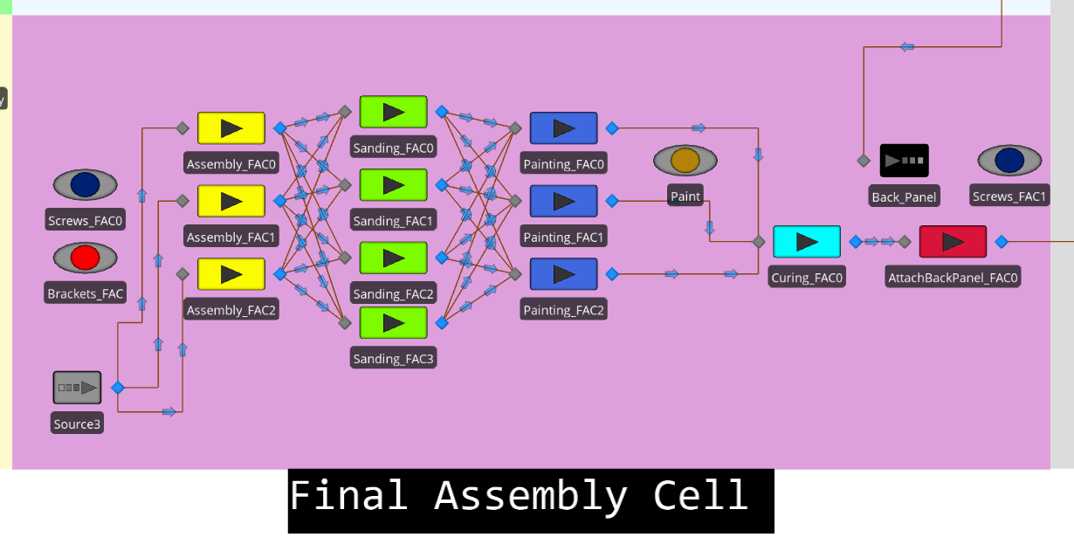

Figure 8: Overview of Workflow for the Final Assembly Cell

While this gave us our first glimpse at the complexity we would face while modeling the core manufacturing process, we only slightly explored the external factors that influenced the system. We were able to leverage this workflow abstract to initiate our input analysis and distribution fitting for the processing times.

## 1.4 Modeling Overview & Process Logic

Expanding on the external factors and refining the process flow throughout the production cells we eventually came to a fully developed base model as seen below. This represented each of the functional areas we established in the initial stages and included many graphical tools to analyze model performance visually. The logic that drove the model heavily relied on add-on processes to facilitate the unique requirements the system faced in real life. This is further discussed in the sections below.

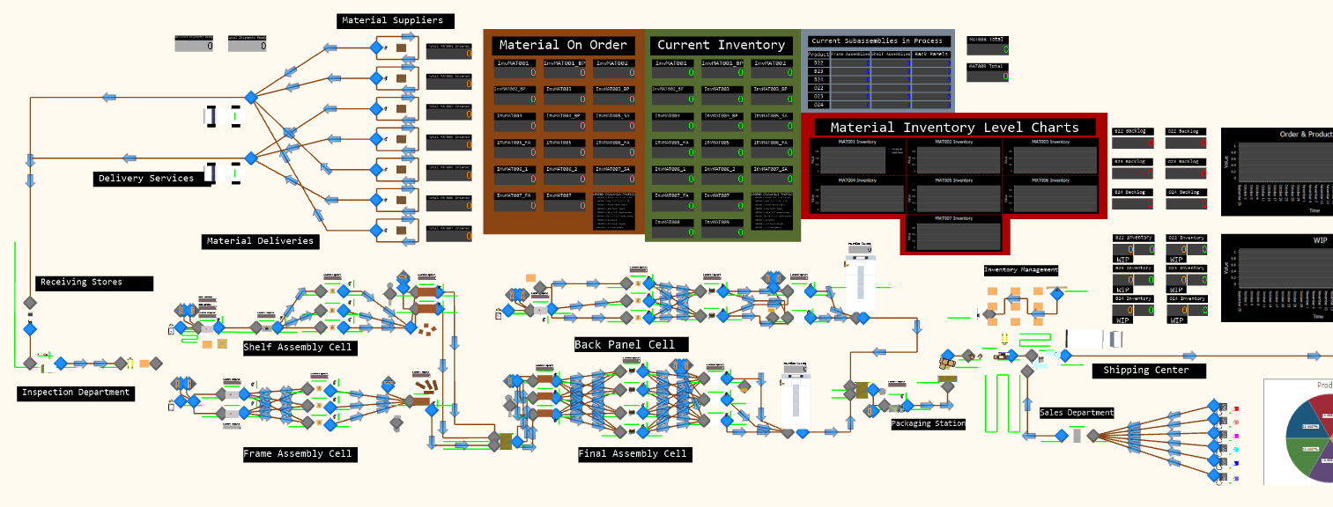

Figure 9: Model Overview

To replicate the random nature of some inputs, we analyzed the provided data with the “Stat:Fit2” tool to fit an appropriate distribution to them. “Stat:Fit” was a key visual tool that helped us understand underlying trends, recognize patterns, and determine the best way to replicate the system by leading us to an appropriate distribution. The “auto:fit” function helped to automatically fit continuous distributions, providing relative comparisons between distribution types to figure out the good fit for the dataset to model the randomness of the system. It also displayed the shape, histogram and graphical analysis of the distributions that allowed us to better analyze how some inputs were distributed. Some of the strategies that we needed to consider in order to find a good fit were to change the width of the histograms, change the number bins utilized, and exclude the outlier. Once we completed the input analysis of all the variables associated with customer arrivals, processing times for each type of station in each cell, percent of defective units of material received, material inspection time in the quality department, and lead time for suppliers we set out to program each subsection to perform in the same way as the real system.

Starting with the frontend, incoming orders are modeled as a single entity by day and product type with the number of units required being put as a model entity state variable “OrderSize” which takes the random value from the distribution determined from our input analysis. They are created once at 5pm on weekdays and sent to the sales department modeled as a server.

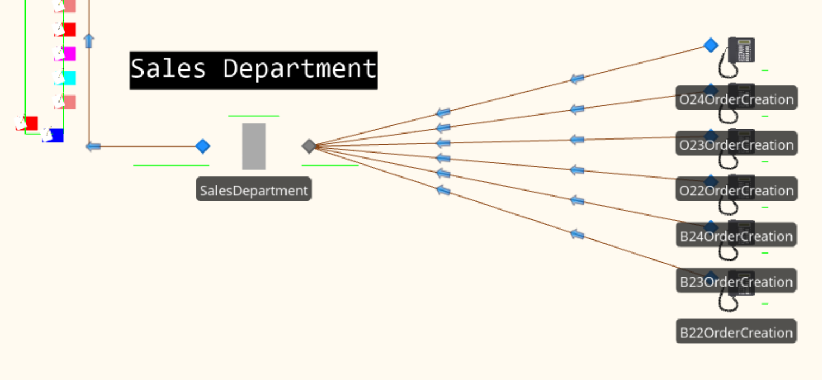

Figure 10: Sales Department Overview

From the Sales Department orders are sent to the next frontend station, the “ShippingCenter” which is modeled as a combiner. Upon entering the “MemberInput” of the Combiner several global variables are modified to account for the new orders.

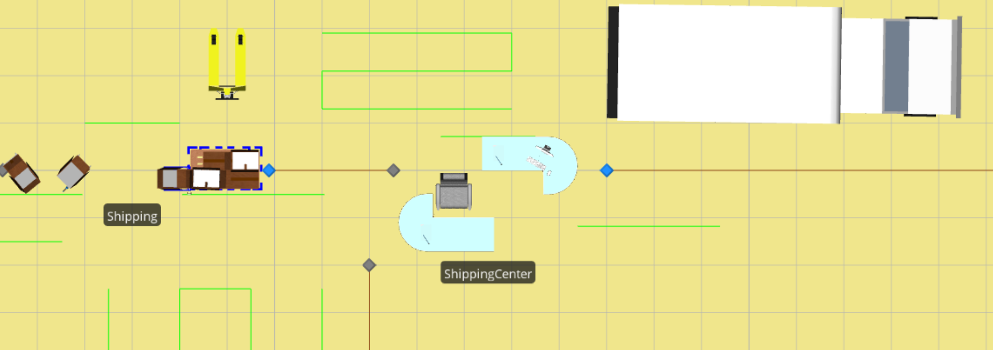

Figure 11: Shipping Overview

These variables modified by state assignments calculate the potential backlog when demand outpaces the ability to produce enough products to maintain inventory levels. Each product type has its own backlog variable to track this and this value is used to help drive production and provides a convenient way to graph backlog data.

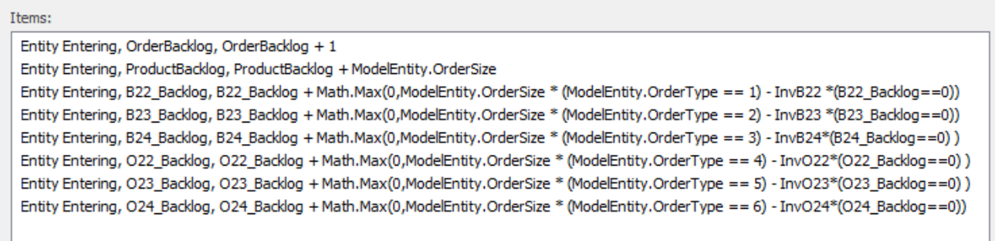

Figure 12: Backlog Logic

Simultaneously an Inventory Reviewer, modeled as another entity, is generated and destroyed at the “Stockup_PaperWork '' sink. Upon the destruction of the reviewer the restock logic is initiated as an add on process.

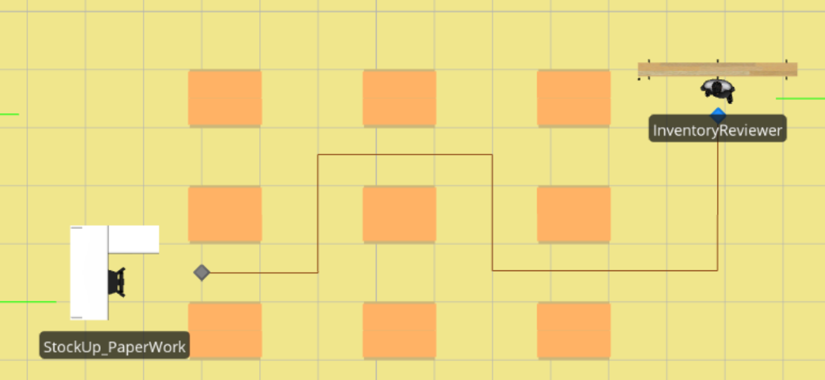

Figure 13: Inventory Review

The main block of the restock add-on processes runs by running multiple execute steps which subsequently run the restock logic for each of the product types and the raw materials needed.



Figure 14: Product Restock Logic Chain

A specific function is dedicated to restocking each product that runs by first checking the current inventory level and work in progress against the reorder limit and the potential backlog. If Inventory and work in progress is below the sum of the other two values then the order type is assigned to a global variable and the specific number of back panels, shelf assemblies, and frame assemblies to correct this are generated. Each part is then given the appropriate order type and the appropriate node is set to transfer the part to. After creating the parts, the work in progress and backlog values are updated.

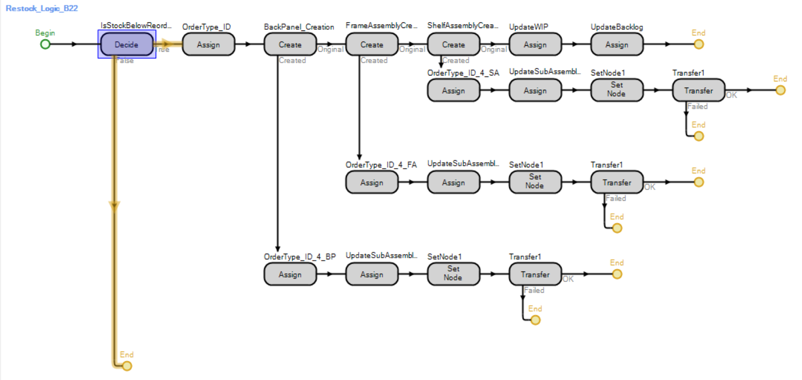

Figure 15: Restock Product Logic

Raw materials are reordered by executing another chain of execution step which run functions that check the value, create a new material entity if required and set the appropriate node to transfer based on the supplier. This is done for each raw material.

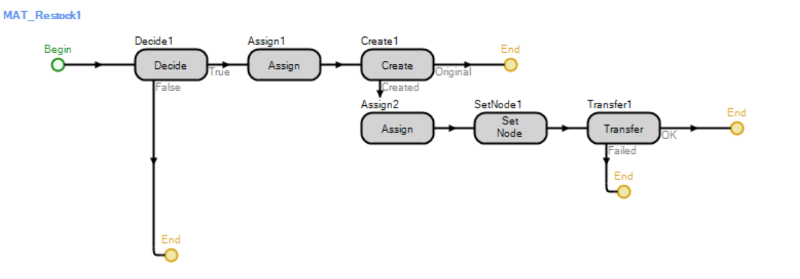

Materials that are created are given a supplier ID by state assignment. Then transporters deliver these materials across time paths which have their time derived from distributions with parameters generated from fitting the lead time data.

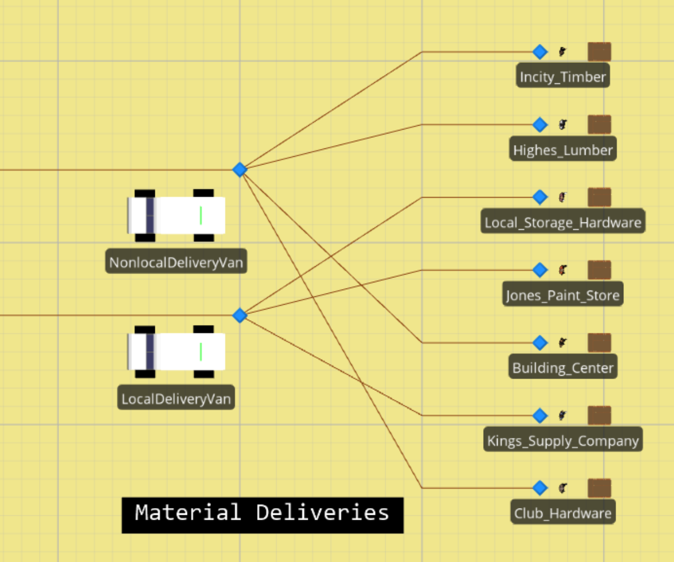

Figure 15: Material Suppliers and Deliveries

Two transporters are set on a schedule for delivery depending on if the supplier is local or not. Utilizing work schedules for the transporters performs the task of ensuring local suppliers deliver at 9:00 am and non-local suppliers deliver at 11:00 am. Since it is not mentioned in the problem description it is assumed delivery times are factored into the lead time and are thus negligible.

Materials are delivered from nonlocal and local suppliers to the receiving station first. This station doesn’t have a processing time but servers to adjust some key ModelEntity state variables. After departing from receiving, material arrives at the inspection station where the inspector is modeled as a server and given a processing time based on the distribution found from our input analysis. Prior to and after processing material state assignments are made to update several values such as the number of units on order but waiting on delivery from the supplier. Leaving the inspection station, the material entity enters the material allocation sink. Upon exiting the sink an add-on process is run that allocates material based on a material check ID given to it in the material restock add on process. Going through a linear process of logically checking for the ID corresponding to each material station, it matches this number through simple logic chains and then restocks the associated material bin. This add-on process also simultaneously releases units held due to stockouts from the stockout holding shelf.

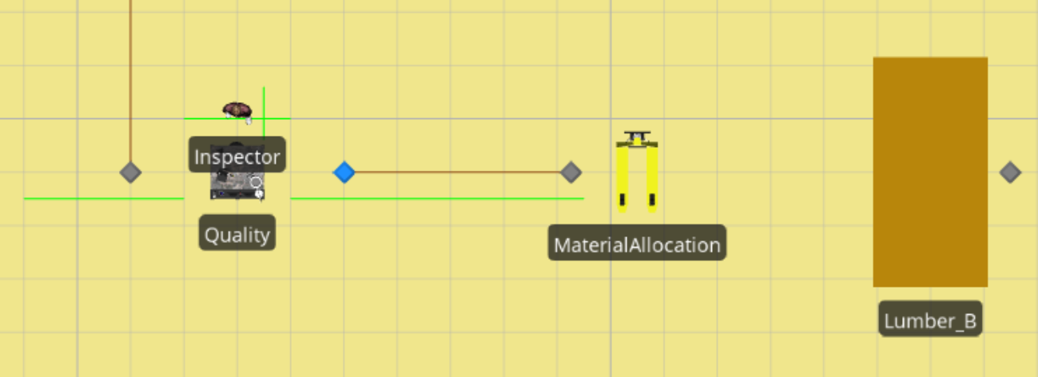

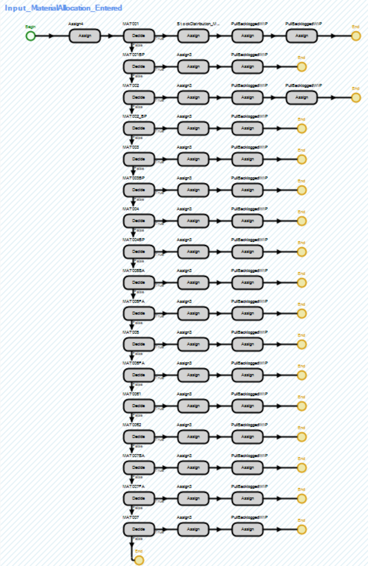

The stations that are restocked supply the four cellular manufacturing blocks of the process which include the shelf assembly cell, frame assembly cell, back panel assembly cell, and final assembly cell. Each of these cells are modeled in a similar manner. Diagrams from the model are given for each on the following page.

Shelf Assembly Cell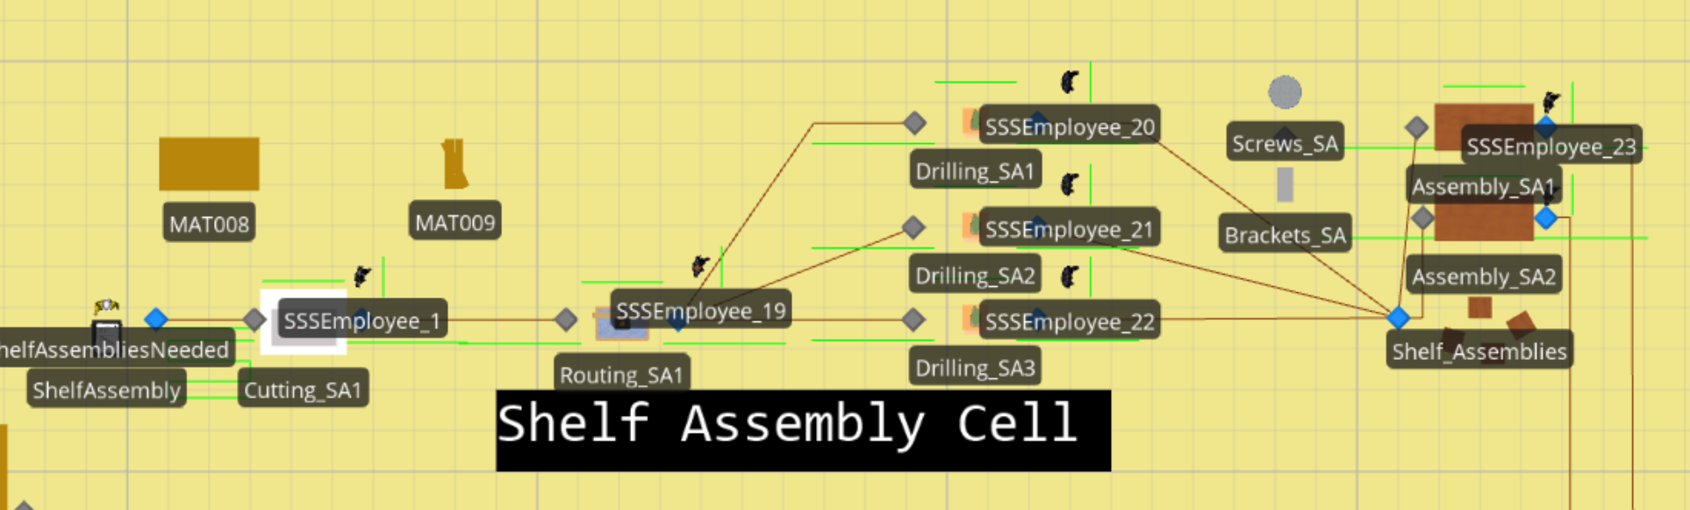

Frame Assembly Cell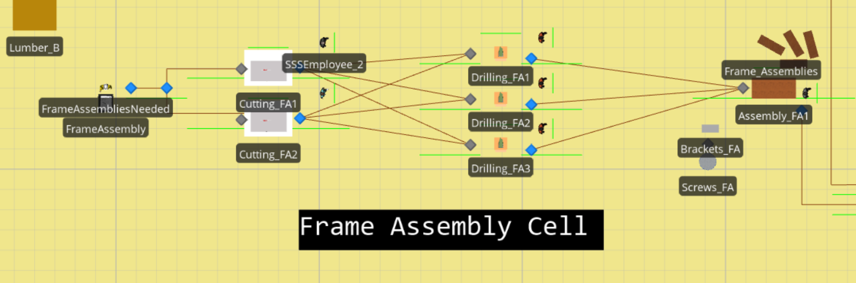

Back Panel Assembly Cell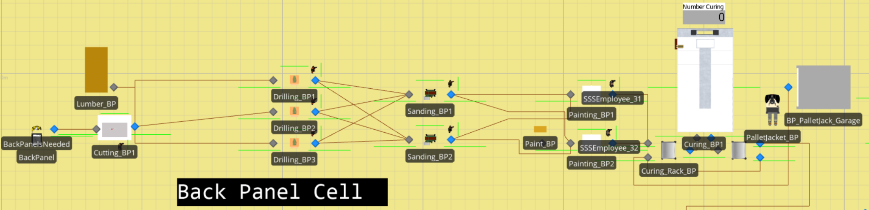

Final Assembly Cell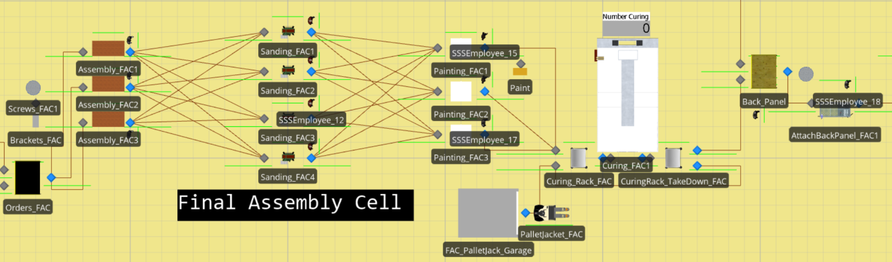

Using the back-panel cell as a representative example for all of them the process begins at the “ShelfAssembliesNeeded” source which is set as the destination node for newly created back panel entities. They go from here to the cutting, routing, sanding, painting, and curing stations where they use a task sequence to process each part and workers to move the work in progress. Steps in the task list are given for each step including getting materials, setting up the equipment, and performing the work.

Figure Task Sequence Example

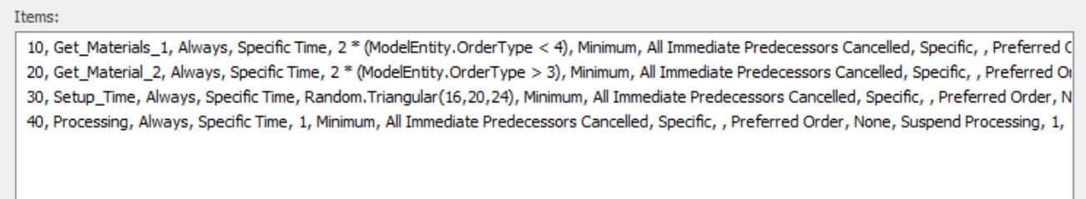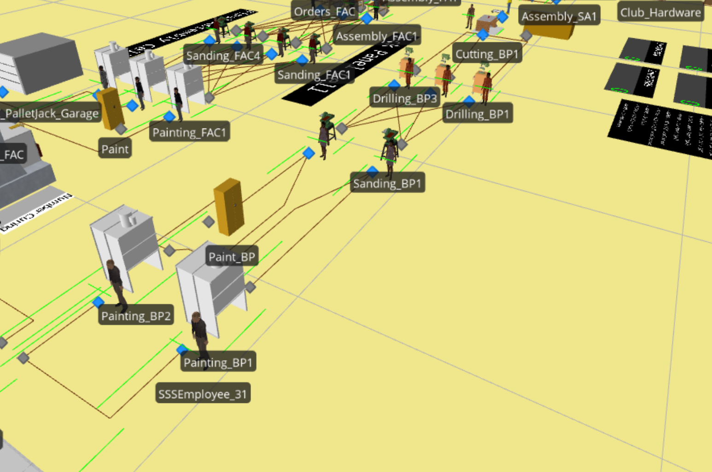

Workers are given generic names in the format “SSSEmployee_[ID]” since they are randomly assigned, and several workers could work at each station. We do this by assuming output does not vary based on worker skill or experience. Inspection is the only station that violates this by having a worker named inspector accounting for the 33rd employee but this does not have any impact on the station’s output.

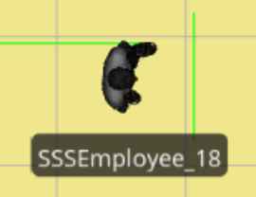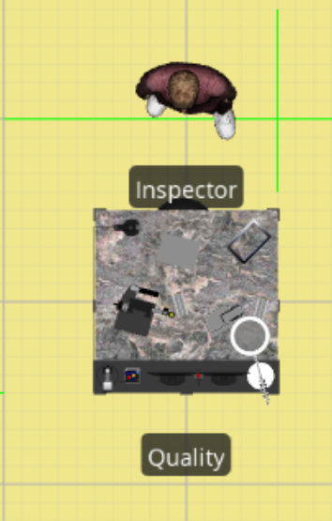

The shelf is assembled throughout the process by combiners which merge the parts. There are two combiners which accomplish this with one for combining the shelf and frame assemblies and then another to combine the shelf and frame assembly with the back panel. The Shelf and Frame Combiner and the back panel are shown below respectively.

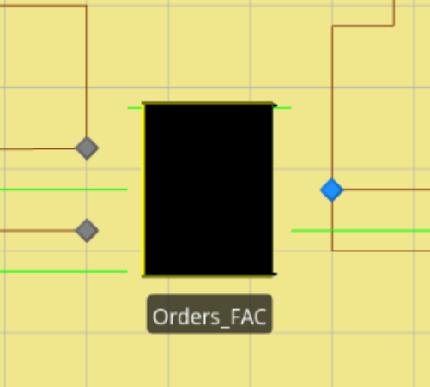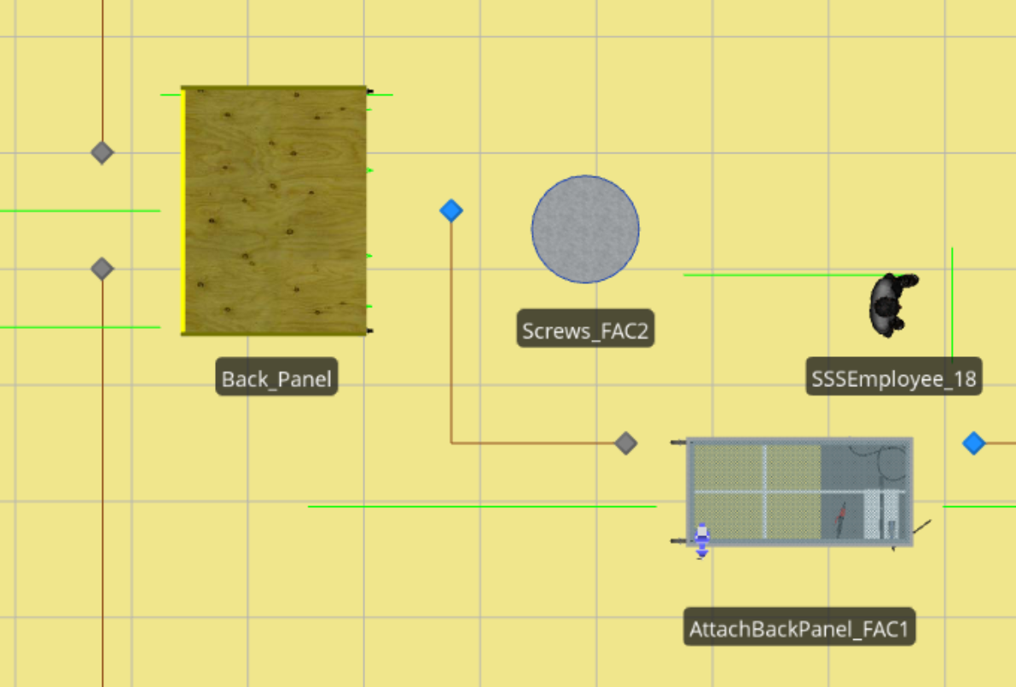

Finished orders are sent to the packing area modeled by a sink which uses an add on process to generate packaged shelves for storage. This process takes the order type and assigns it to a new shelf variable which replaces the individual product pieces represented by individual entities.

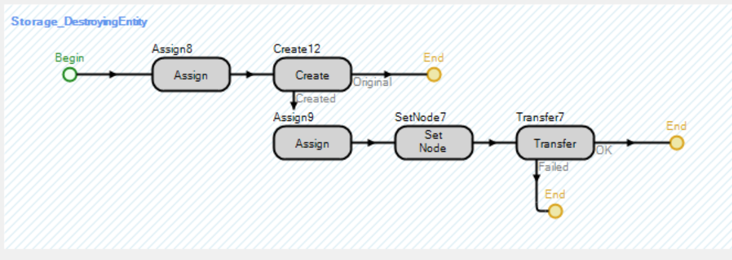

We also included extensive data visualization for checking model performance. The charts, graphs, and labels can be observed live to check a myriad of activities going on during the model run such as work in progress, inventory, backlog, raw material, and sub assembly levels and graphs for work in progress, order backlog, and production mix. These data visualization sections include one for stats up close while watching the model run and another that provides a full screen of information including KPIs for the system.

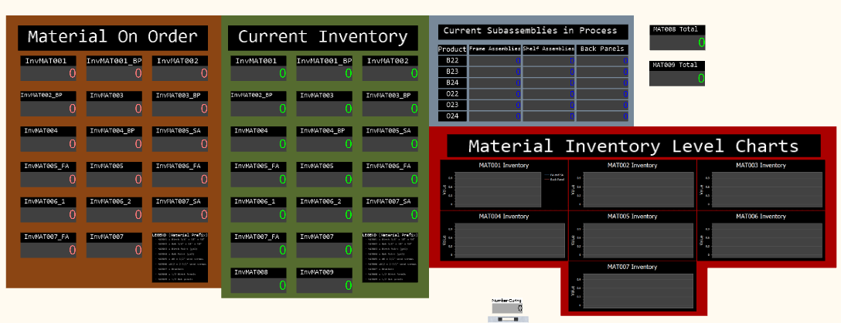

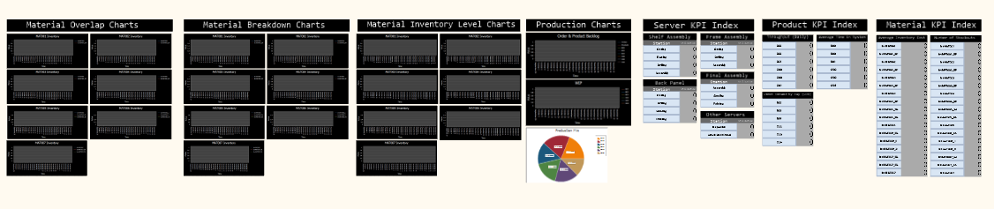

# 

# 2. BACKGROUND

## 2.1 Assumptions

To make this project a success, the team has made few assumptions in terms of project management. The first assumption that was made is the customers only make one order on a single day consisting of multiple units. This assumption allows us to aggregate the total number of units into one order by type per day that is sent to sales. Next assumption we have made is that the worker output does not vary depending on the worker even though they are randomly assigned, we have designated one for each station. Furthermore, we have assumed that the delivery time consists of the given time and we assume the length of delivery time is factored into the lead time. The final assumption we have made is that the similar stations in a manufacturing cell performing the same process should have statistically insignificant times between processing since they are using the same equipment to manufacture identical parts and workers are freely switched between them. All these assumptions will help us to control the system to complete the project successfully.

## 2.2 Problem Background

The Simio Shelving Shop is a sprawling facility that is setup to manufacture cellular shelving units with several different design configurations. These configurations include two options for wood and three options for shelf configuration resulting in six options to choose from. To accommodate the various configurations offered, the factory utilizes a cellular layout that is split into four manufacturing units along with receiving and shipping areas. There are three manufacturing units, including Shelf Assembly, Frame Assembly, and Back Panel, rely on Receiving to supply raw materials to create sub-assemblies which are passed with some additional raw materials to the fourth manufacturing unit, Final Assembly, to bring them together and form the finish product to be delivered to shipping and on to the customer. Though this system presents model workflow principles and disciplined work practices, it is still subject to some shortfalls. Recent order fulfillment data has brought management’s attention to an ongoing issue where orders are not being satisfied due to the lack of necessary materials, known as “stockout”.

## 2.3 Strategies for Consideration

The factory currently uses static buffer levels, where raw material buffers are supplied by a simplistic min-max policy. This policy dictates when material is ordered based on a predetermined minimum level. Once a buffer reaches that level or drops below it, an order will be generated by a daily stock review at 5 pm while conducting the standard inventory review process. The order will seek to return the stock of the material back to a preset maximum level, ignoring any latency in fulfillment. To improve the company’s Key Performance Indicators (KPIs) for metrics such as order fill rate or throughout, a replacement for the static buffer system will be considered. The plan will involve implementing a dynamic buffering system which a recent consultant to the company thinks will resolve the “stockout” issues and increase the overall productivity of the manufacturing process at the facility. The dynamic buffering system will allow restock amounts to keep pace with demand by growing and shrinking based on certain values they are purposely correlated with.

# 3.DATA ANALYSIS

## 3.1 Initial Findings

Below are histograms, generated from Python’s Matplotlib library, representing the distribution of every station involved in the shelf manufacturing process. Observing these distributions, we noticed that stations of the same type from the same manufacturing cell typically resembled each other in shape and further review of actual production results support the relationship to one another. This led us to roll these datasets together and apply a single fit for all stations that displayed this trend.

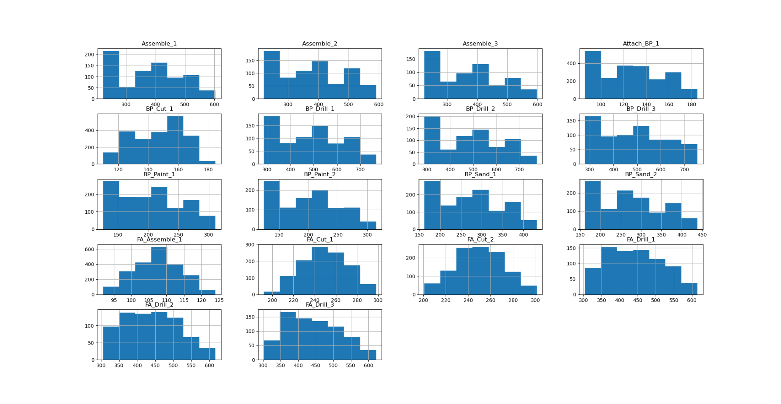

Figure : Processing Time Histograms Continued

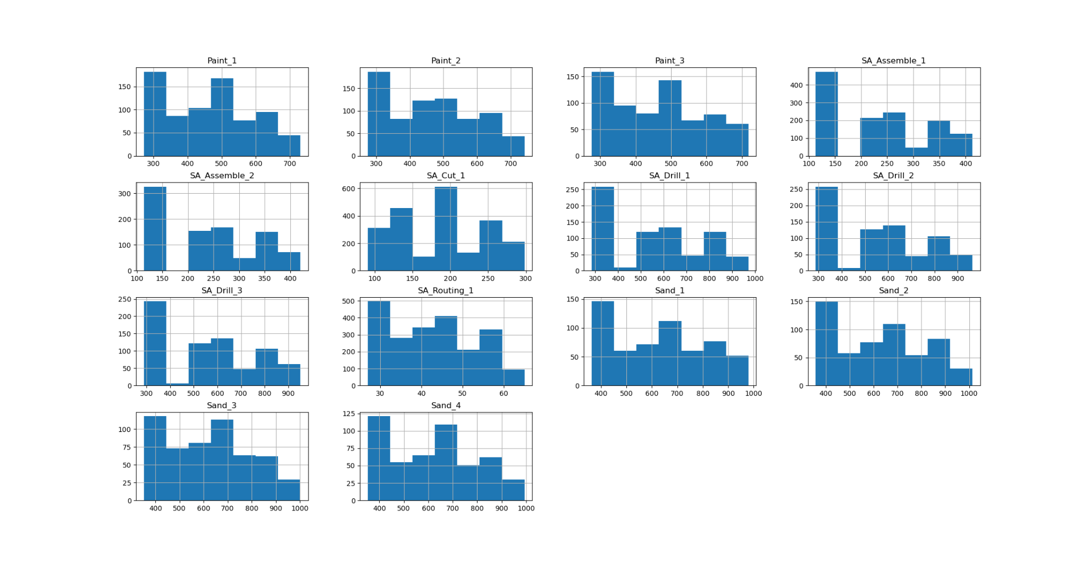

## 3.2 Input Analysis & distribution fitting

Distribution fitting had to be performed on 53 individual data sets to obtain the proper distributions to accurately model the inherent randomness of the system. As seen below these data ranged from many different areas in the model but mostly came from processing times at server workstations for the production cells.

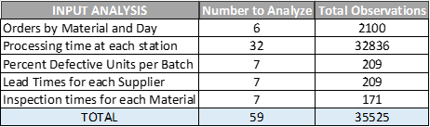

From the initial findings, we saw that similar stations in a manufacturing cell performing the same process had statistically insignificant processing times between one another. We reasoned this would be the case since the primary factor most likely impacting processing time would be the machine, but since workers would probably be using extremely similar machines, on the identical parts or products, with the same level of training. Since workers were also switched between workstations daily it would also be fair to say that any large variation in method by one worker over another would have a negligible impact on the difference in time between the two. By taking advantage of this trend, we were able to cut down on the number of datasets to fit for processing times from 32 to 15. Some quick analysis on stations such as the 3 assembly stations at the beginning of the final assembly cell help confirm this as seen below.

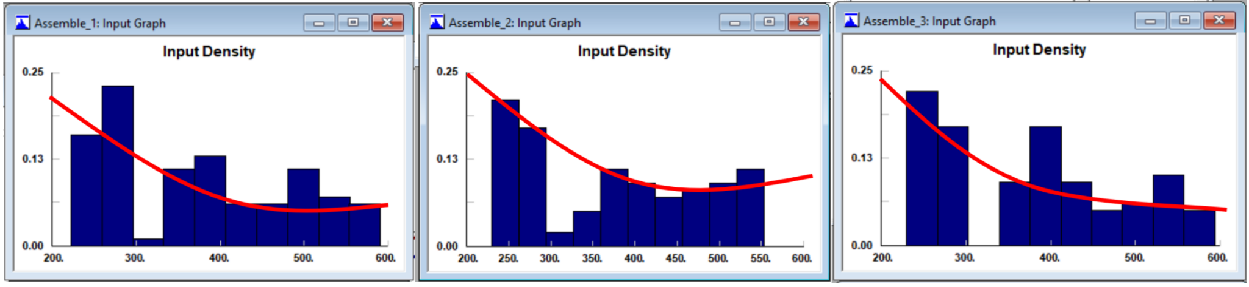

This is further evident when looking at the provided production data. By examining the average production time for groups of similar stations in the same cell, we found that there existed little difference. Shown below are all grouped stations and their average processing time from the provided data set.

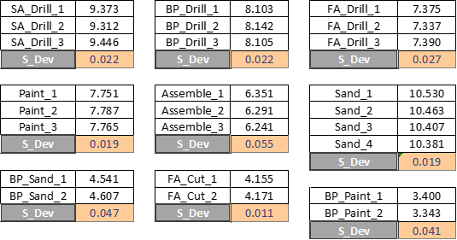

To analyze the individual datasets for fitting distributions to each station, entity, and state variable, many tools were used, including MATLAB, Python, and StatFit. Some of the most helpful tools from these programs included the distribution fitters, goodness of fit tests, comparison graphs, PP plots, QQ plots, and box plot charts. These tools went far beyond just a simple eye test and allow for correlations to be quickly identified. Some examples of the work are posted on the following page with all of the analysis listed in the input analysis section.

B22 product arrival data comparison using a P-P plot.

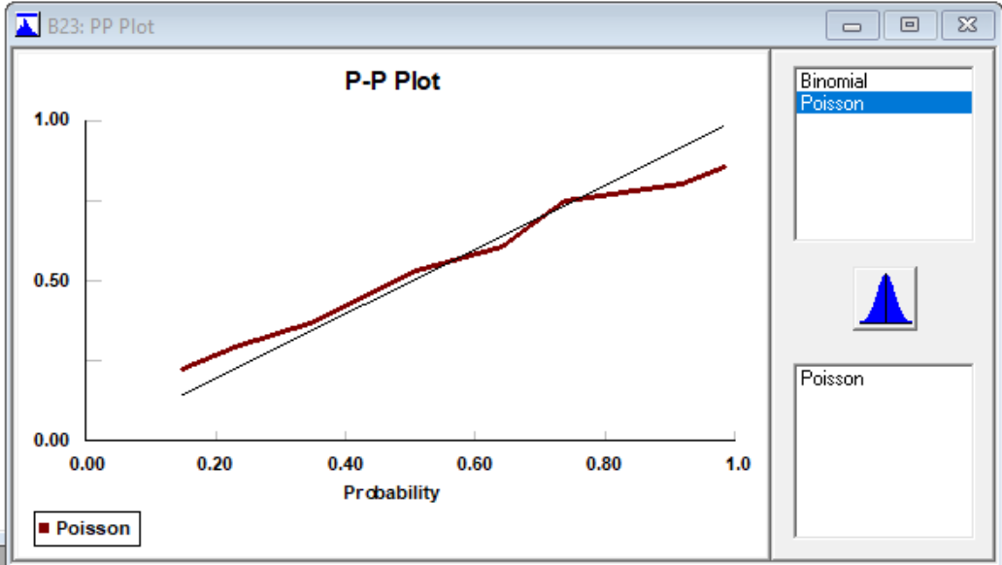

B24 product arrival data comparison using a P-P plot.

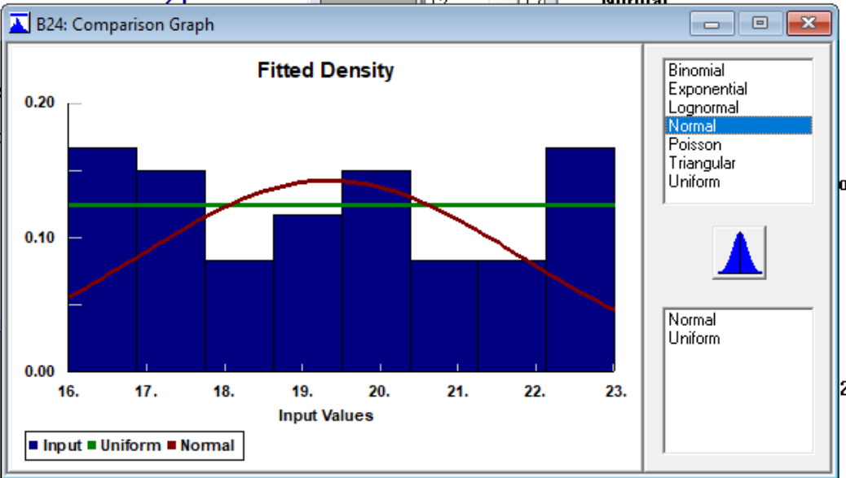

Comparing distributions for O22 product arrivals using a box plot.

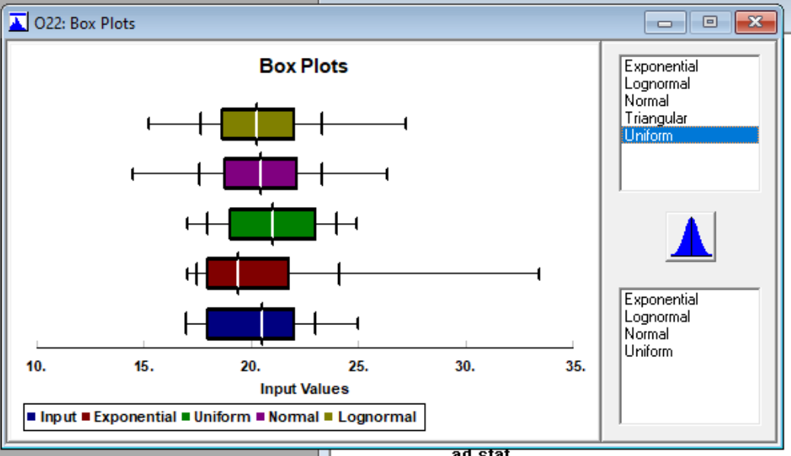

## 

## 3.3 Trends & Key Information

We were able to find some interesting trends not only from our simulation runs but by observing the historical data given. From the data gathered on suppliers for raw materials, we found that certain types of products tended to have higher levels of defective units with the highest being any lumber supplier.

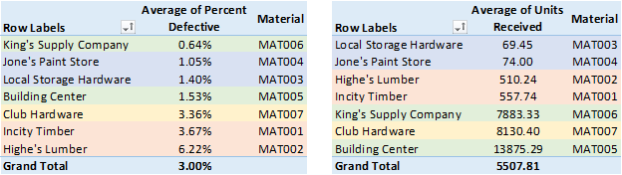

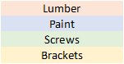

This also led to the discovery that insufficient sample sizes were obtained for some suppliers which we mitigated by making empirical observations to determine that the amount of time to receive some raw materials from local suppliers could be omitted as they did not have any impact on the simulation outcome. Later model verification steps help to ensure that these assumptions did not severely skew to the results in our final model.

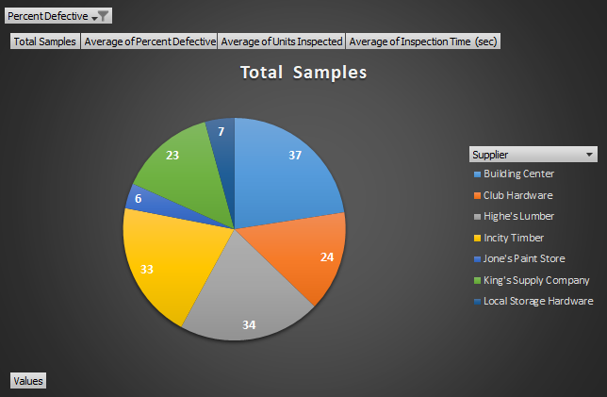

While reviewing different charts we also noticed that some trends from the order data for raw material in the original dataset showed some odd patterns. Most materials showed consistent orders over the initial half of the period observed but, afterwards several started to show inconsistent and unstable order patterns. We, at first, thought that this may have been attributed to the original restocking policy tending to over commit to certain resources early in the production process leading to inconsistent stock level towards the end of the data set. However, we later found that these trends were a good indicator of stockouts upstream in the workflow.

Figure : MAT005 Order Arrivals

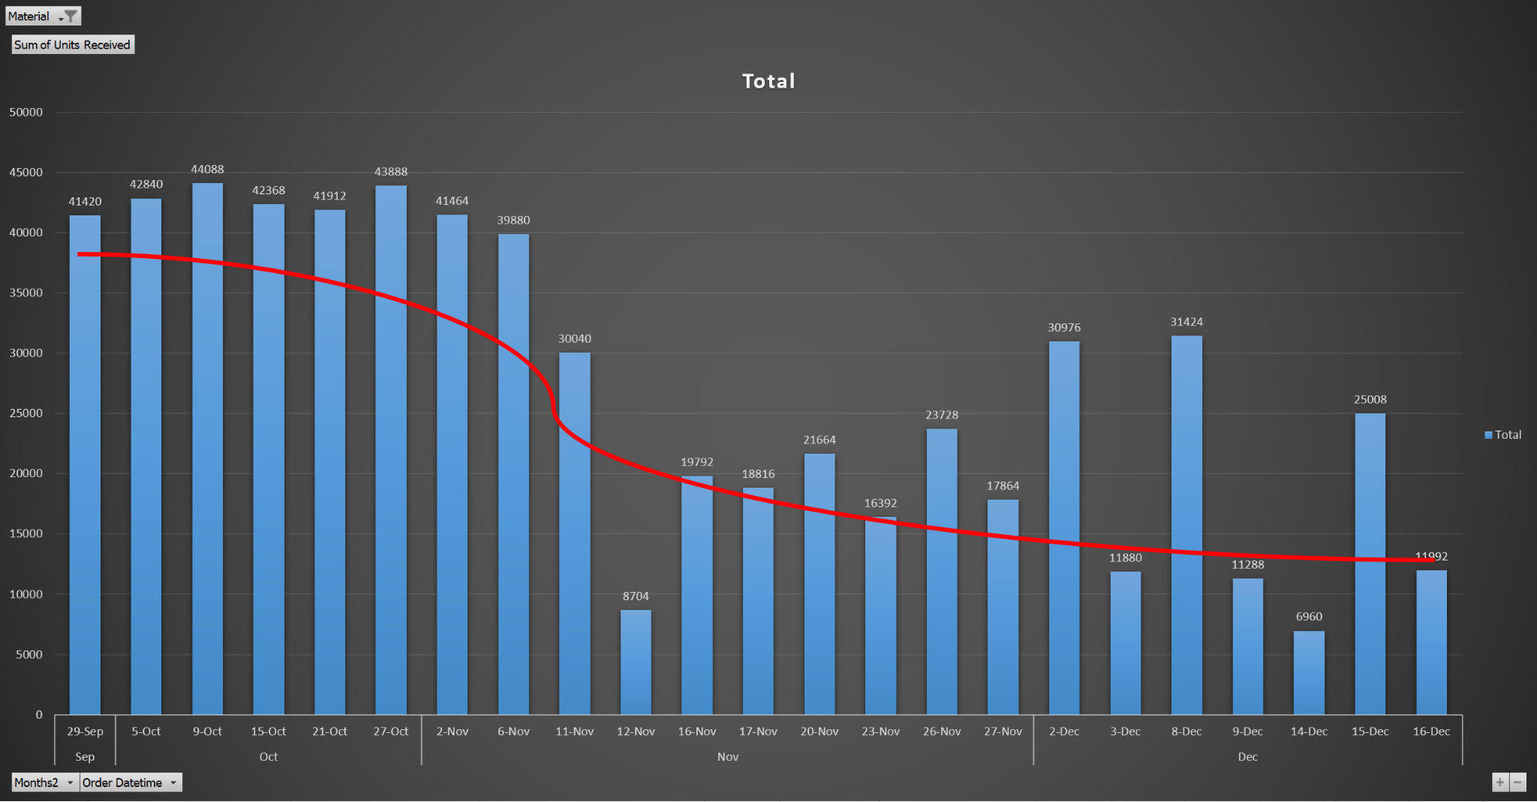

Figure : MAT006 Order Arrivals

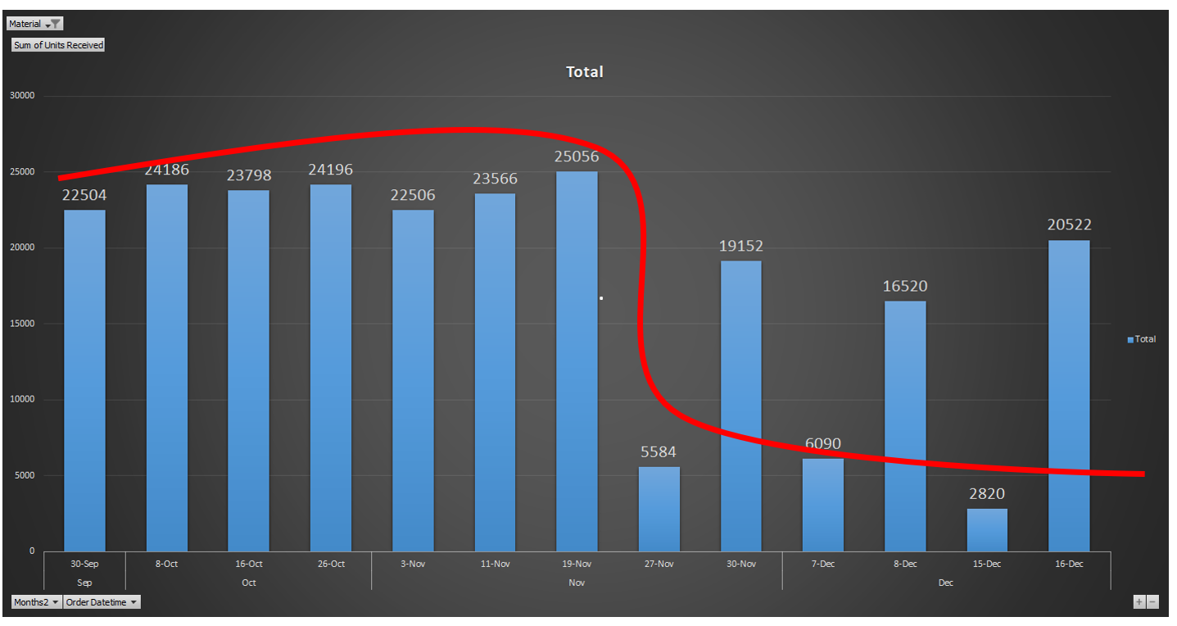

## 3.4 Model Verification & Validation

After we finally completed building the model, fitting the data, setting parameters, and cleaning up aesthetics, we moved to verify that our model truly represented the original system with a relatively high degree of accuracy. Even though we had been checking for alignment with the original system all along, once we finally had a finished and fully functioning model, we could move to check some output and results data. First, we reviewed the most obvious comparison factors which were those stated in the project guide provided by Simio. As per their description, expected average weekly throughput was supposed to average between 600 and 620 units with average unit production time approximating to 46 hours for each. Our initial trial run yielded a total of 7,163 units for a 12-week period which led to our model’s average weekly throughout being equal to (7,163/12) = 597 units per week only 0.005% outside of the specified range that was already approximate. We were able to safely attribute this slight deviation to the uncertainty of the system which far exceeded this in many instances. We next evaluated the unit production time of the system by evaluating the “ShelfAssembly” ModelEntity output results from our initial model. We reasoned that selecting any individual part originating at the same time including the “FrameAssembly”, “ShelfAssembly”, or “BackPanel” ModelEntity would give us the result we wanted since their time in the manufacturing plant were all the same. This gave us an average unit production time of 44.25 hours. This result was extremely close to the value given as the addition of 15 randomly distributed variables being included in the model logic. The final test we used was comparing production distribution for customer orders. Examining pie charts, shown below, for these distributions from both our models initial runs and the data provided we found them to be extremely close and possibly on target if not for a rounding error. With these and other verification and validation steps we felt assured our model accurately replicated the systems behavior.

Figure : Supplied Data Versus Model Data

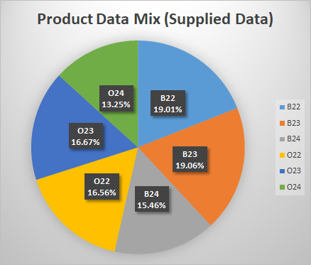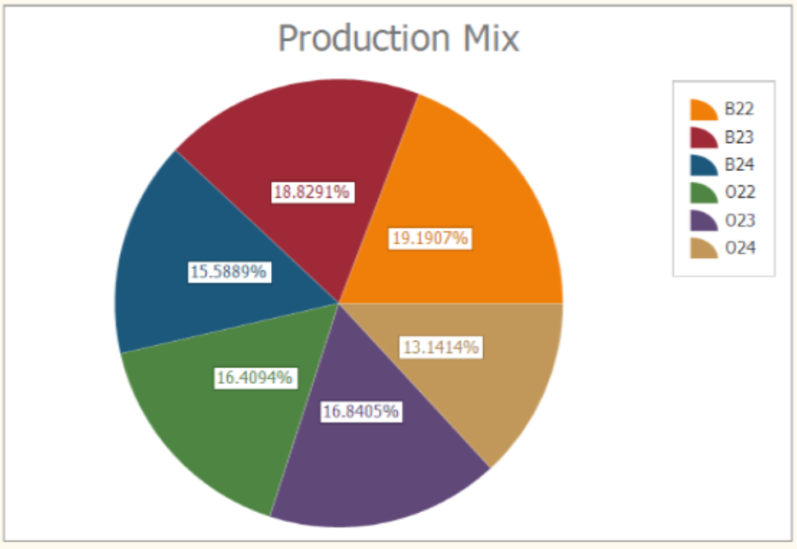

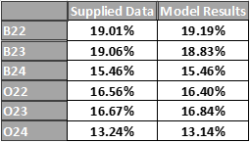

# 

# 4. MODIFICATIONS

## 4.1 DDMRP

Demand Driven Material Planning Requirements (DDMRP) is an operational supply planning and scheduling methodology that reduces the bullwhip effect and promotes supply chain flow by creating and managing strategically placed inventory buffers. This methodology replaced the factory’s current static buffering system and drove down instances of stockout and improved selected key performance indicators that are management's highest priority. This new implemented technique helped to manage inventories that have shortages and overstocks and improved the visibility for supply order execution that have large demand variations.

We implemented the exact model from the literature as recommended by the consultant with only minor deviation. Following his plan, we utilized zone profiles which calculated green, red, and yellow zones each time a stock review was done and incorporated updated data from runs on the same day. This modification did have some additional requirements such as state variables for specific material minimum order quantities “MOQ” and for supplier lead time. The minimum order quantity was pulled straight from the supplier’s material requirements while material lead time was drawn from the mean of the fitted distribution. The additional state variables that were needed were those for calculate the unmet demand per day. Since it is described as an automatically updating value, we had to place variables for the previous day's end of day stock and unmet daily demand for the specific material. The additional state variables that were needed are listed below.

Figure : State Variables for DDMRP Implementation

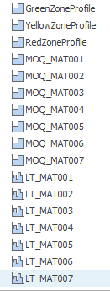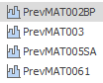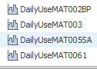

## 4.2 Process Structural Changes

While actual structural changes to the entities and objects in the model might impact the realism of the model, making changes to the underlying process logic can be relatively easy. These changes can reflect low cost solutions that can be done without resource intensive jobs to change fixed equipment in a system. They can often mimic work process changes that can be driven by management. That is the same thought process that led us to the modification made to our model that enabled the adaption of a DDMRP in the Simio Shelving Shop Simulation.

To accomplish these changes, we examined the stockout data from the base model simulation run and identified specific materials that were experiencing the greatest number of stockouts. These included InvMAT002_BP (oak planks dedicated for back panels), InvMAT003 (paint dedicated for the final assembly cell), InvMAT005_SA (woods screws for shelving assemblies), and InvMAT006_1 (final assembly wood screws for joining the frame and shelf assemblies) with this last material experiencing a much higher number than others as seen below from the initial Material KPI Index.

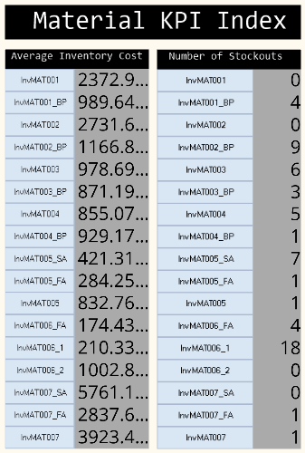

Using a combination of state variables (described previously), property elements, and add-on process steps we implemented dynamic buffers on the material requirements for these items which modified the restock level based on the dynamic inventory model described in the text. This built a minimum reorder point based on the three profiles in the previous section by summing them after calculating their new respective value. This all attempted to follow the described model from the text shown below.

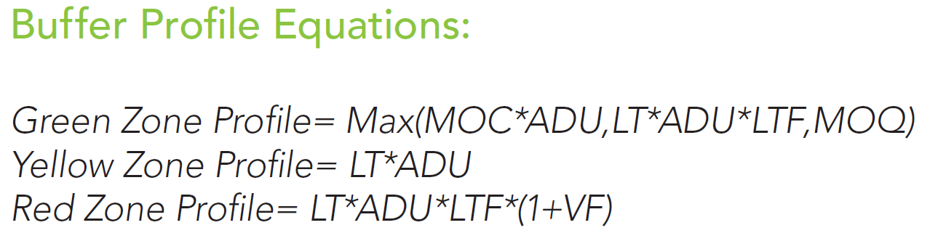

This model facilitated optimization through two user defined factors as input to the equation. The first was the LTF(Lead Time Factor) which played a role in manipulating the green and red zones. The other was the VF(Variability Factor) which only modified the red zone.

For simplicity, we only apply these DDMRP measures on the buffers with the highest instances of stockout during our simulation runs. To make the modification we first listed the state variables that would be needed then restructured the specific material restock buffer logic add-on process. By running the profile calculations just before determining if stock was needed in a new assign step, we were able to evaluate the new profile against the current stock level. Then we had to add one more assigned step to handle reevaluating unmet daily demand and update the previous stock level variable for the next day. These modifications are shown below next to the old restock logic.

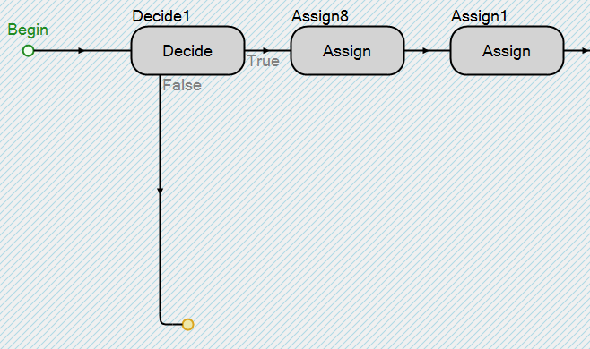

Figure : Old restock logic initiation

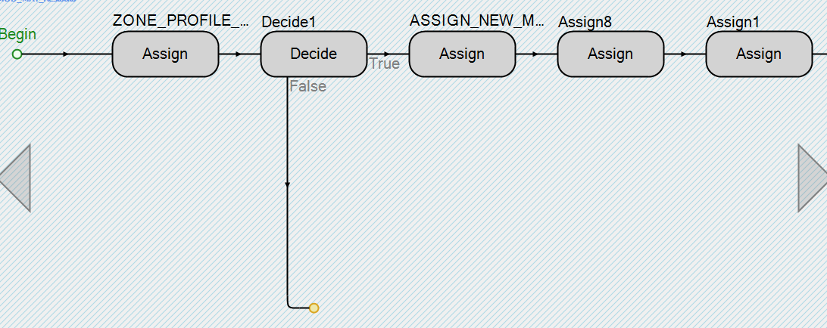

Figure : New restock logic initiation

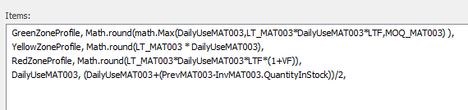

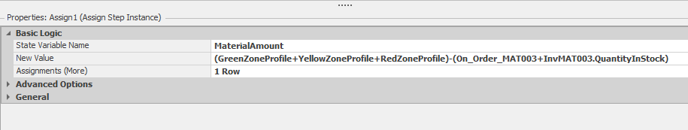

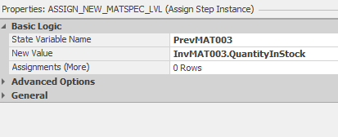

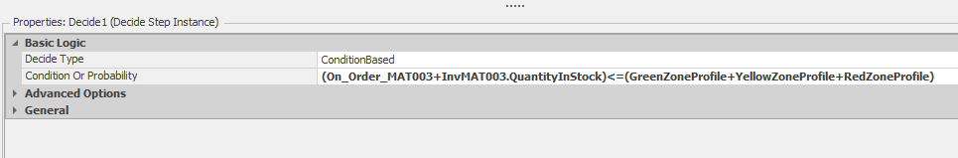

Figure : Restock Calculation Changes (Example InvMAT003)

# 5. DESIGN OF EXPERIMENTS

## 5.1 Selection of Key Responses

To evaluate our model, we examined different variables that could act a response in our experiment to yield the outcomes we desired. Ultimately, we opted for throughput and time in system for units in the model as our first responses. These provided for greater stability with system wide performance considered which facilitated the ability to incorporate responses that were extremely volatile but also provided better control on target resources. These other variables included the number of stockouts, and order cost of the buffers identified by high instances of stockout.



Figure : Experiment Controls and Responses

These responses were necessary due to the fixed LTF and VF factors that would serve as the next part in or experiment design

## 5.2 Experiment Controls

The control selected come straight from the literature and consisted of the LTF and VF factors which would serve to magnify or dampen the order requirement calculated from the profile zones. We opted to keep the range on these controls between 1 and 5 to avoid unnecessary replication with cost far outside the range of our materials cost response set with a minimum objective. The material stockout number response and the time in system for each entity were also set with objectives to minimize while our throughput was set to be a maximization target to the number products in the system by shipping them to customers quicker. Shown below is our model run with 15 scenarios each running between 2 and 6 replications to take advantage of the long run time and a two-week warm up for each replication.

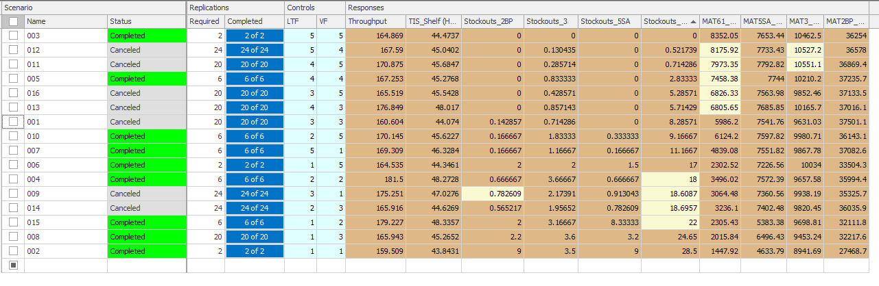Figure : Experiment Run

# 6. RESULTS AND CONCLUSION

## 6.1 Simulation Runs & Results

After selecting our experiment controls and responses based on the new system to be implemented and setting up the experiment we ran a baseline for comparison, then applied OptQuest to it with a minimum of 2 replications per scenario, maximum of 6 replications per scenario and to of 15 scenarios. Next after identifying some potential candidates based on desired outcome, we ran subset selection which further reduced the number acceptable option. Finally, we applied the KN method to find a solution with an indifference of 10 percent which eliminated some potential control values but didn’t clearly identify the best one.

Figure: Baseline Experiment Results

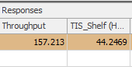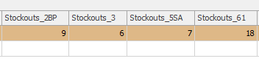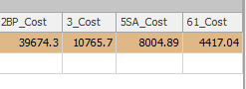

Figure : Best outcome based on the available options



## 6.2 Recommendations

The results from the KN optimization process made us consider several options but ultimately, we settled on the variable inputs, LTF==3 and VF==3. These values offered the best compromise between our many responses from the experiment. Overall, it reduced material stockouts despite some materials experiencing a slight uptick. On this page and the next are side-by comparisons of model KPIs from before modifications to post modifications respectively.

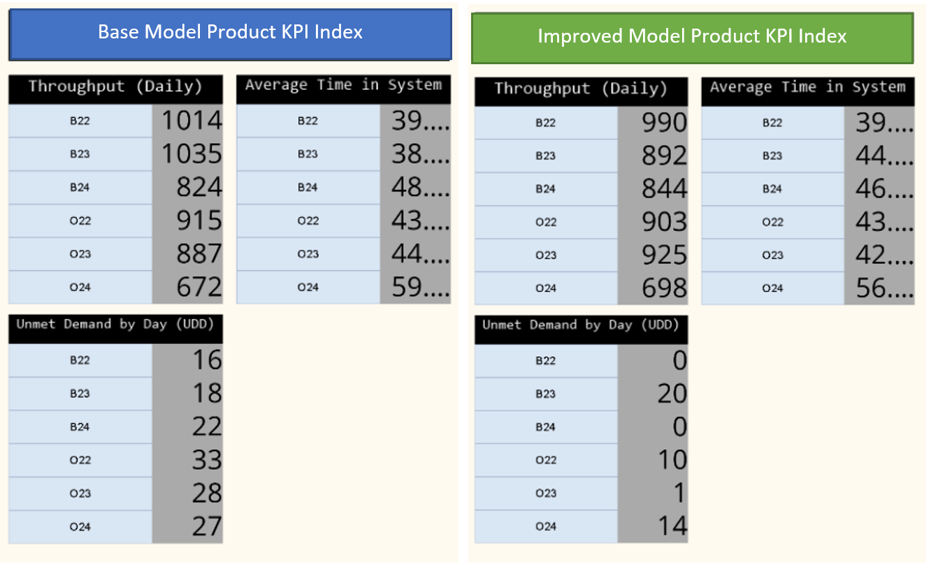

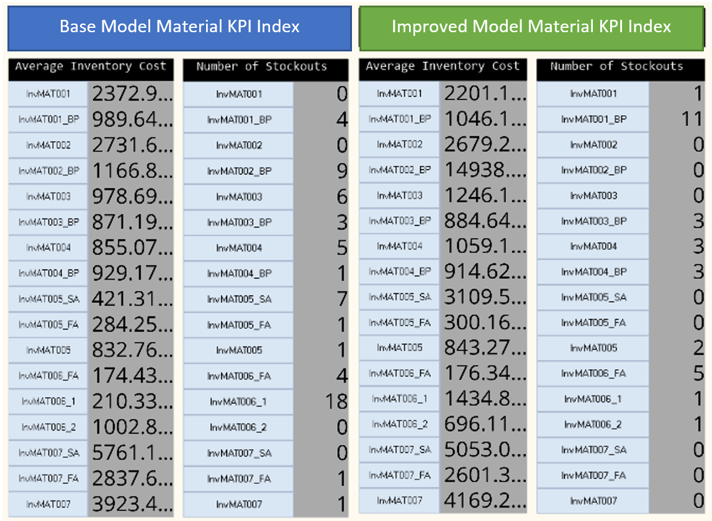

# 7. INPUT ANALYSIS

## 7.1 Order Arrival Distribution Fitting

For order arrivals we ensured that only discrete distributions were used to prevent partial units from occurring since this failed to correctly represent the real-life system.

* B22 Arrival Distribution Fitting (Uniform Distribution)

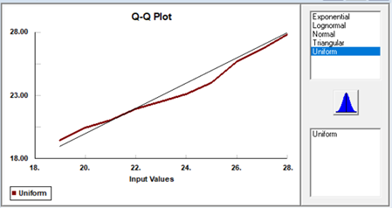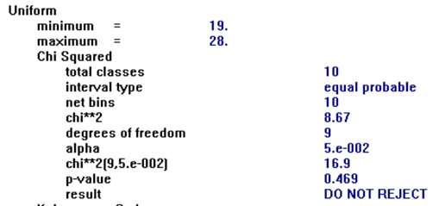

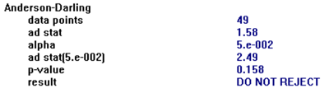

* B22 Arrival Distribution Fitting (Poisson Distribution)



* B22 Arrival Distribution Fitting (Uniform Distribution)

Data was multimodal

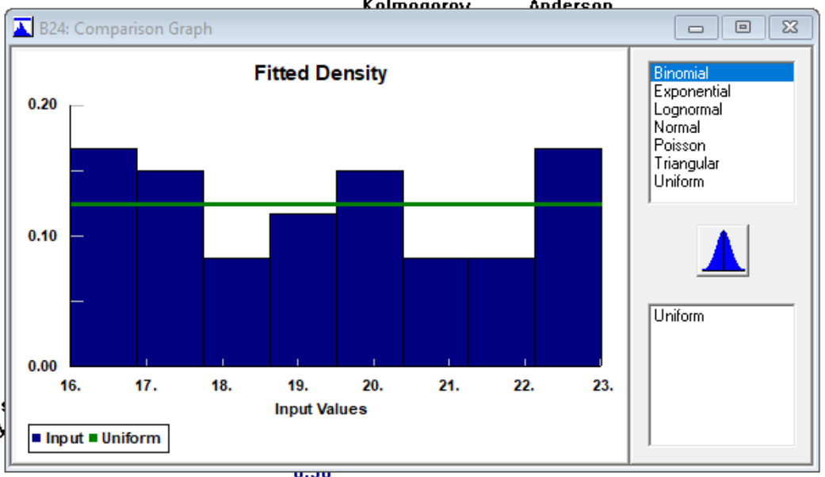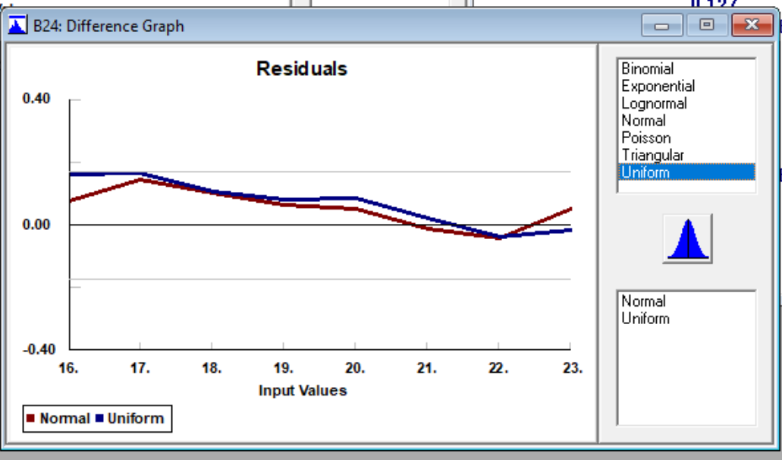

* O22 Arrival Distribution Fitting

Multimodal again so Uniform distribution chosen again even though exponential was a better fit by calculations and yielding discrete values. Observing the range of values, this would result in extreme outliers that might throw off our data.

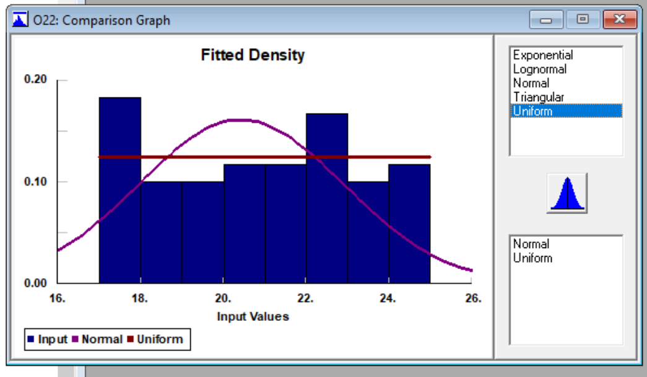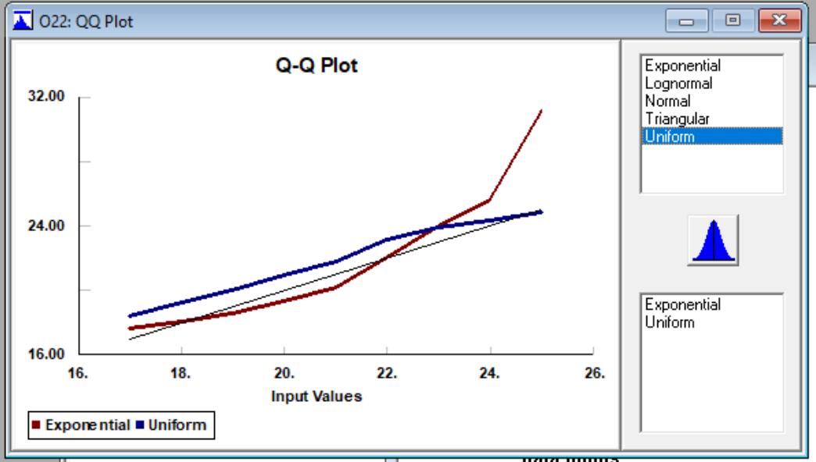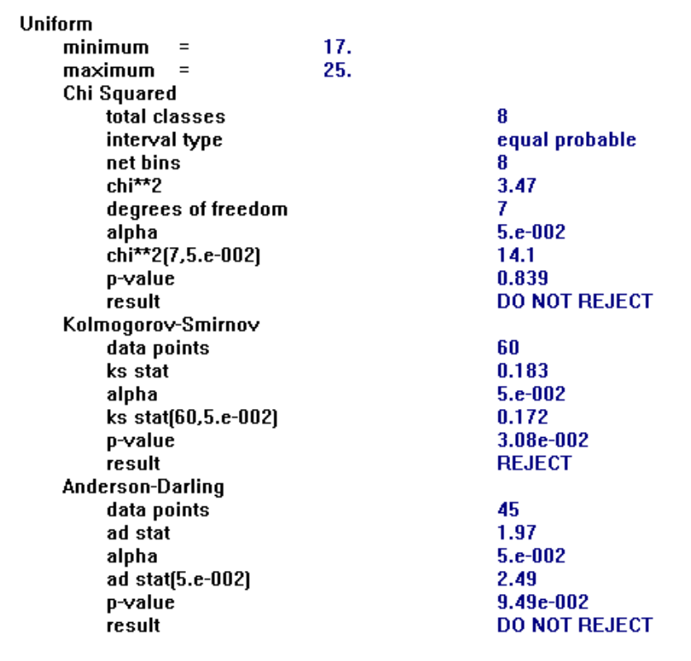

* O23 Arrival Distribution Fitting

Poisson Distribution provided the best fit given the options but uniform again for data

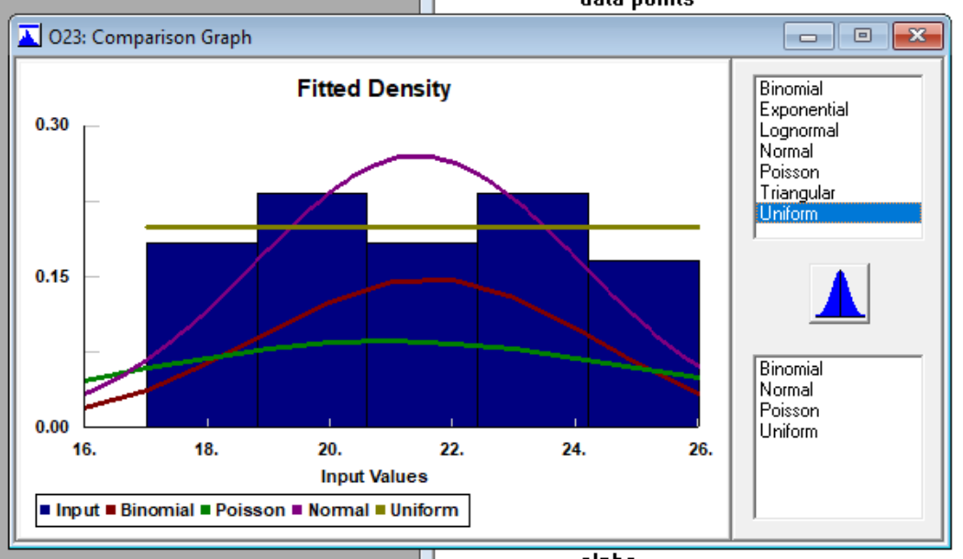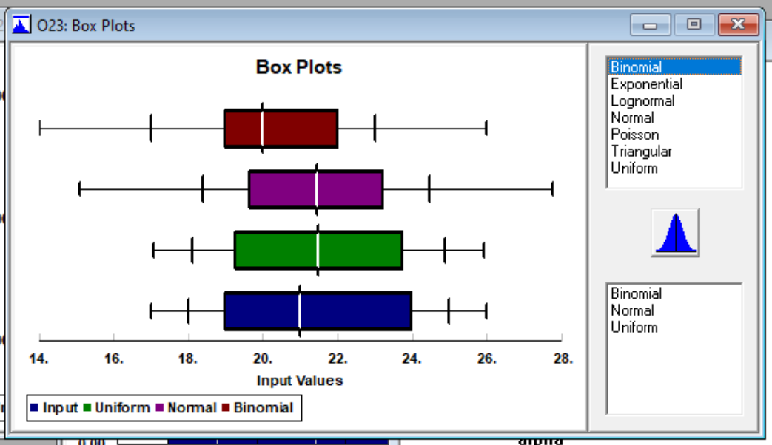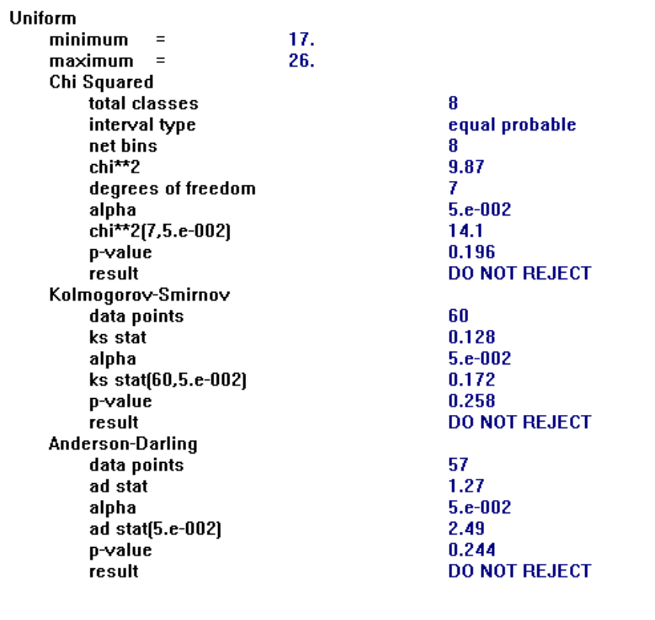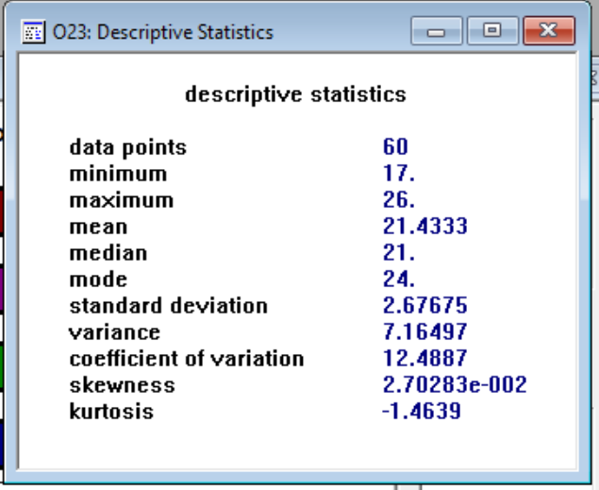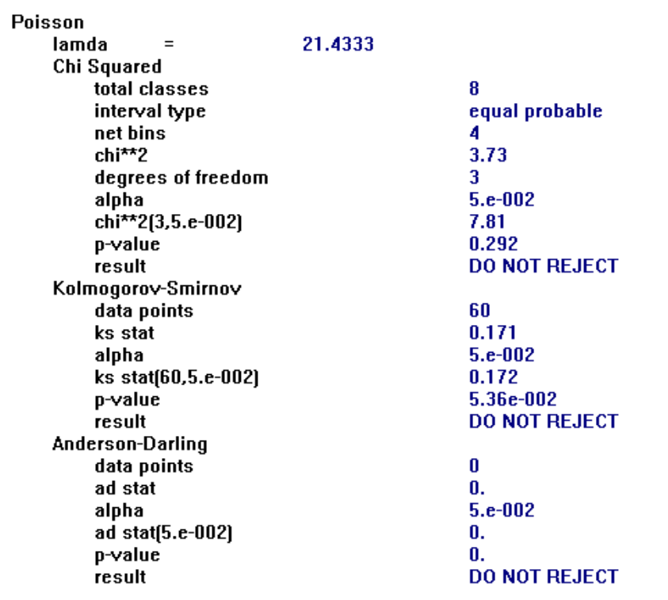

* O24 Arrival Distribution Fitting

Binomial distribution was chosen. Some values fell outside of the range seen in the sample set but the number farthest outside only resulted in numbers 2 to 3 units outside of the dataset.

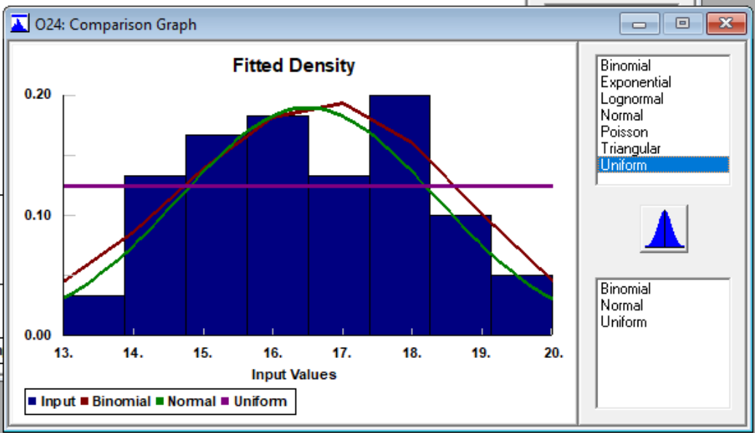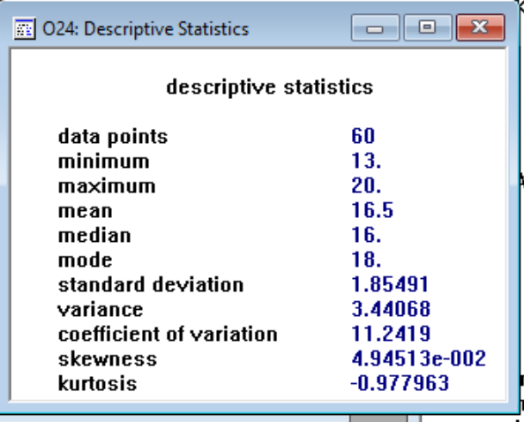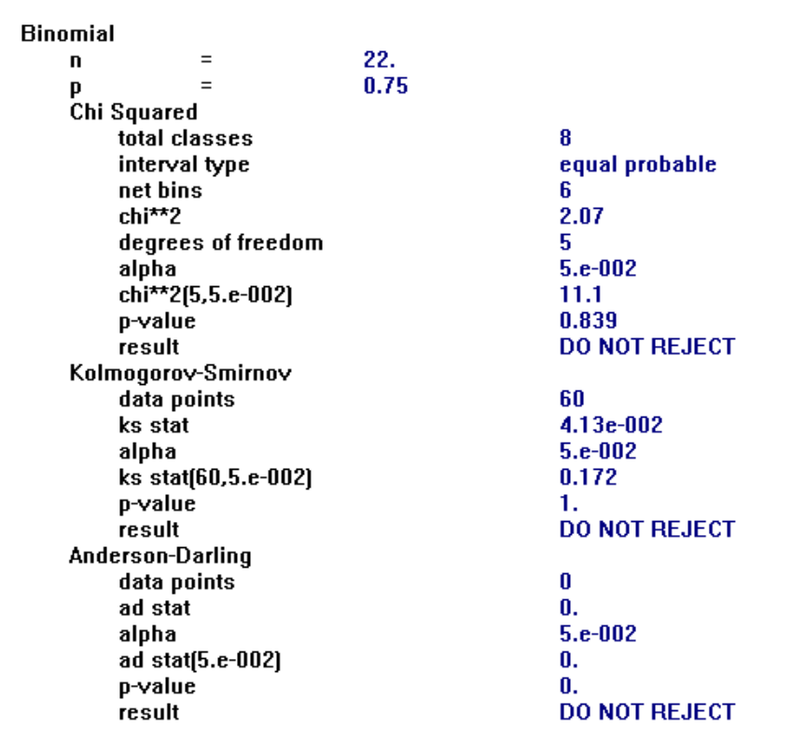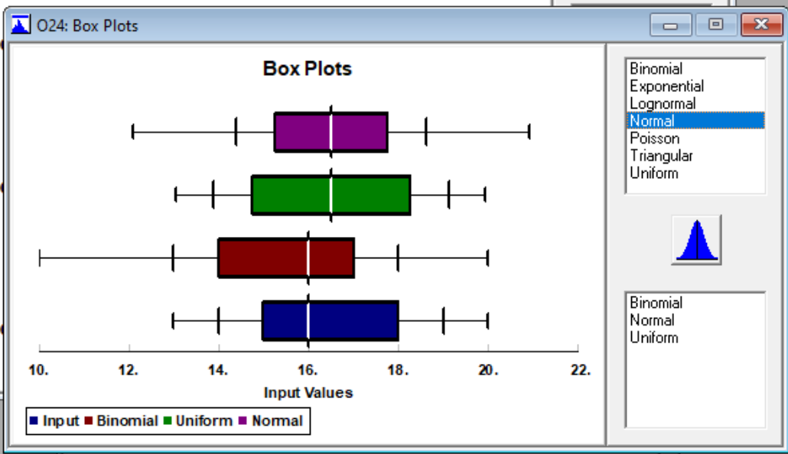

## 7.2 Percent Defective Units Distribution Fitting

# MAT001_PercentDefective

* Uniform Distribution

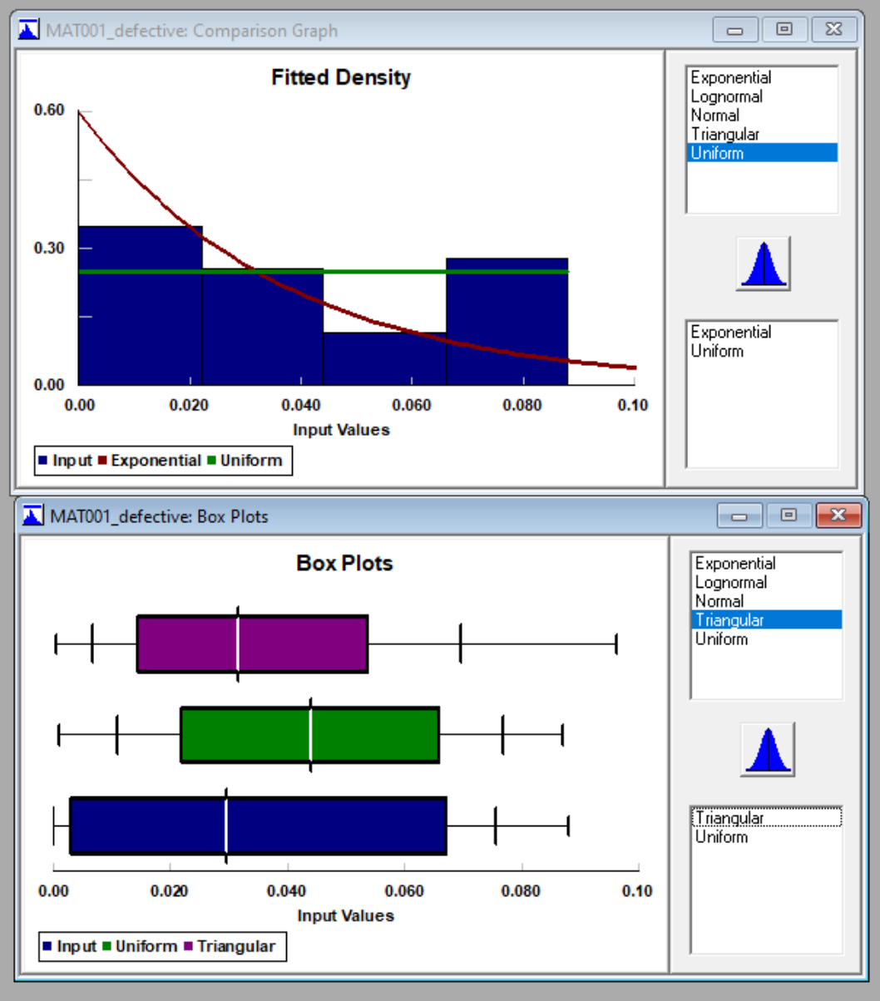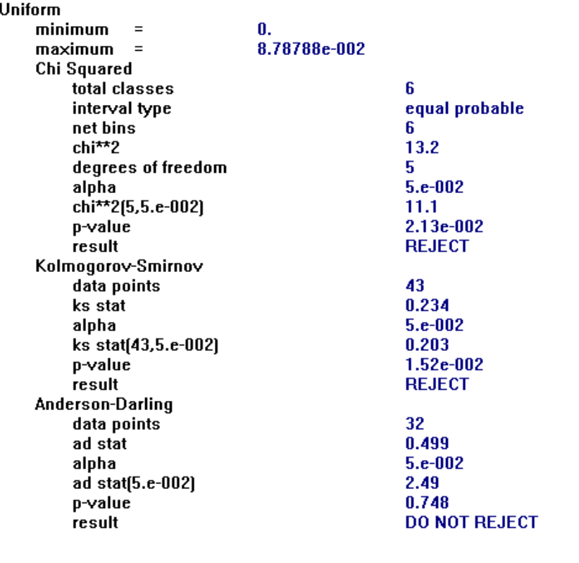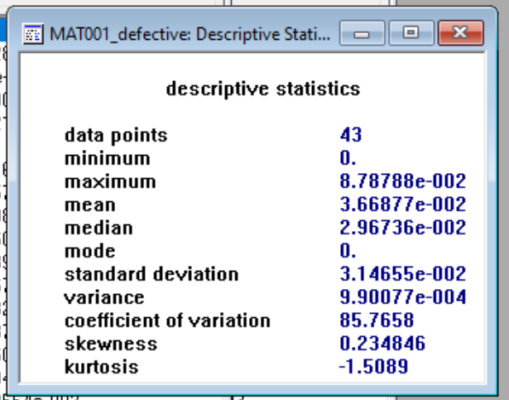

# MAT002_PercentDefective

* Normal Distribution

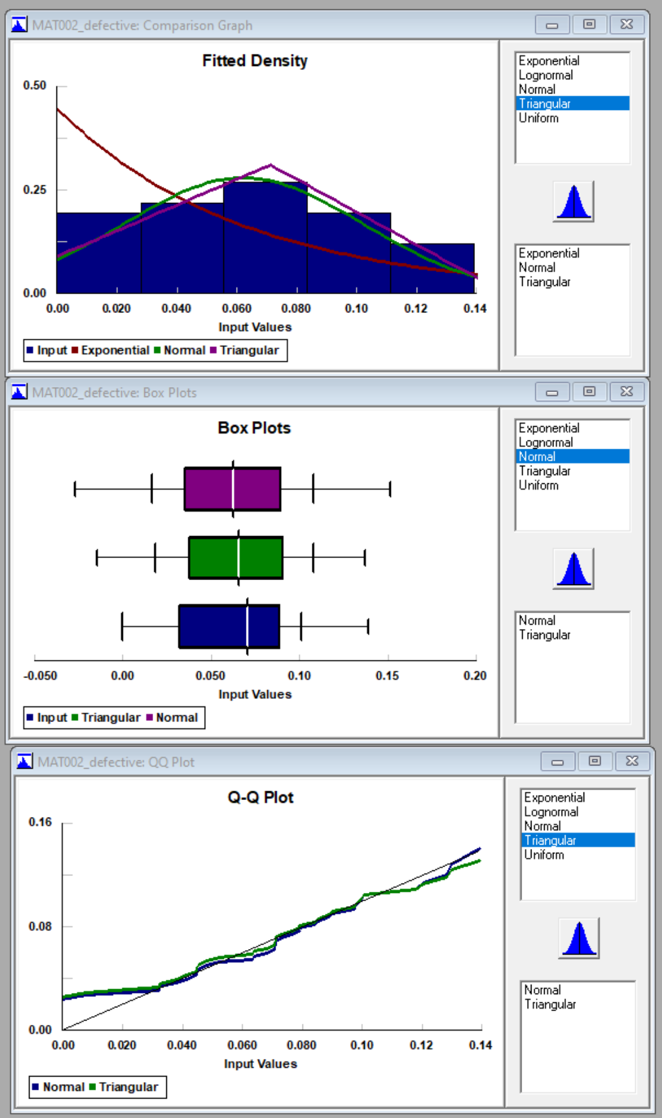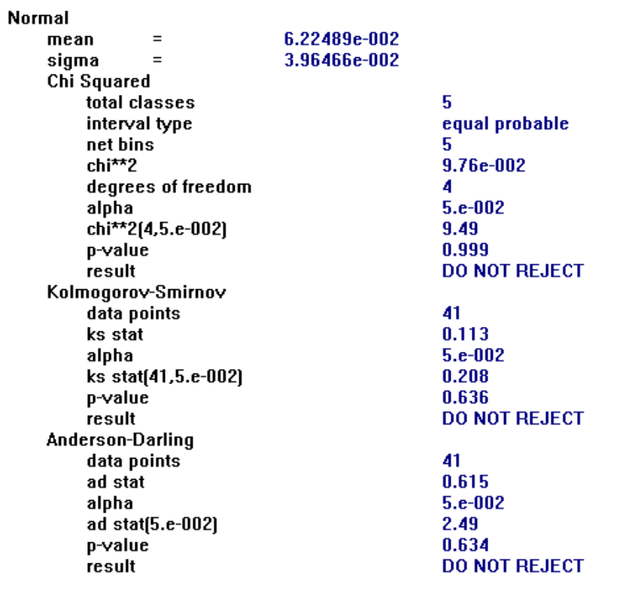

# 

# MAT003_PercentDefective

* Exponential Distribution

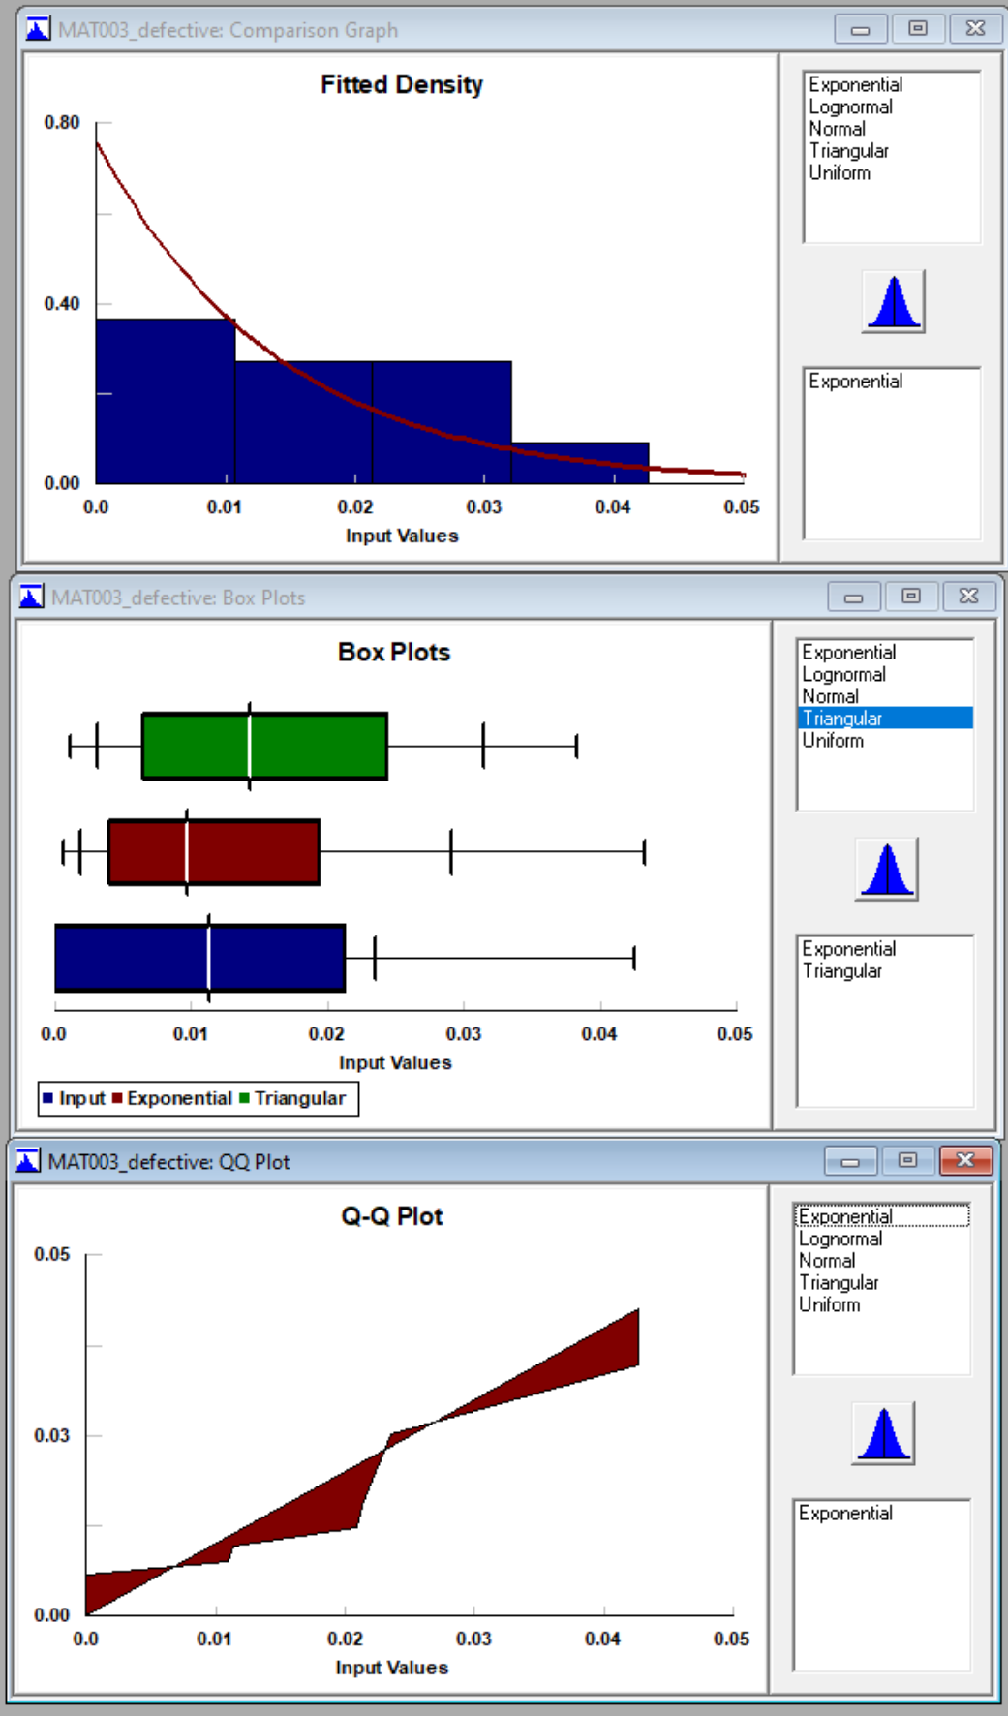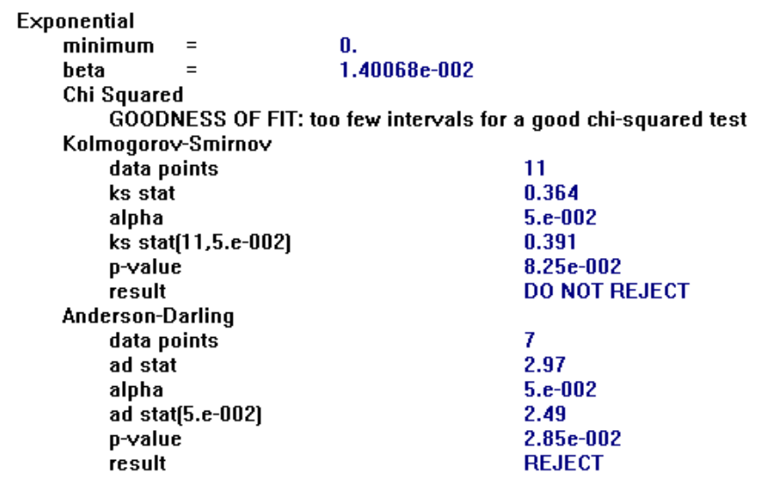

# MAT004_PercentDefective

* Not enough data points to generate valid conclusion, will remain zero

# MAT005_PercentDefective

* Uniform Distribution

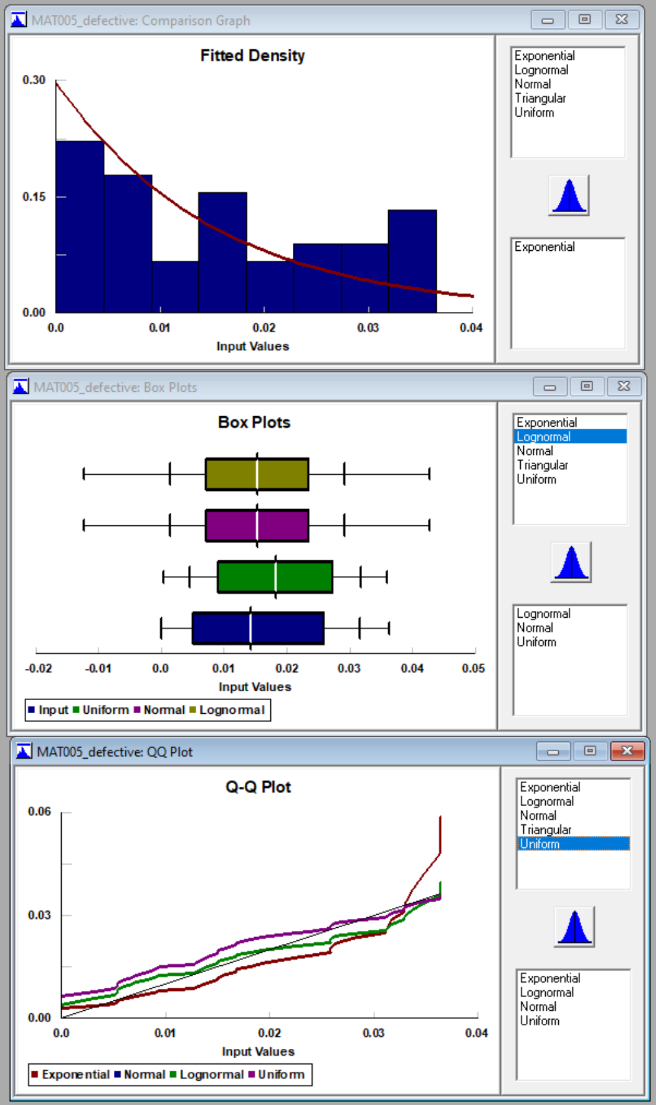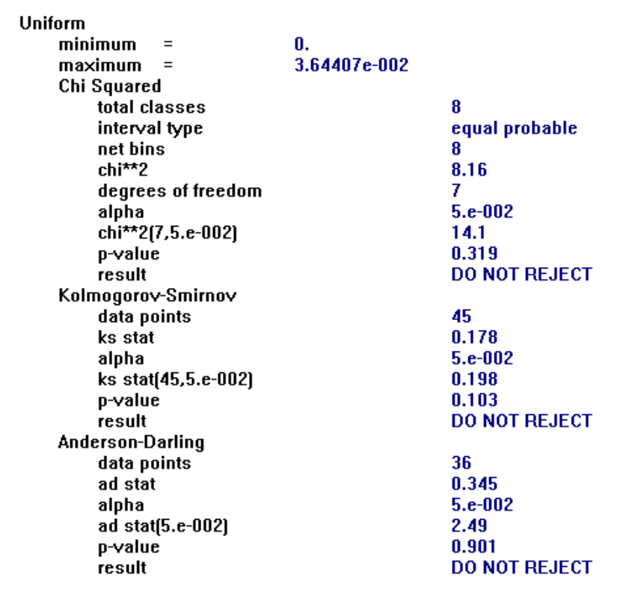

# MAT006_PercentDefective

* Exponential Distribution

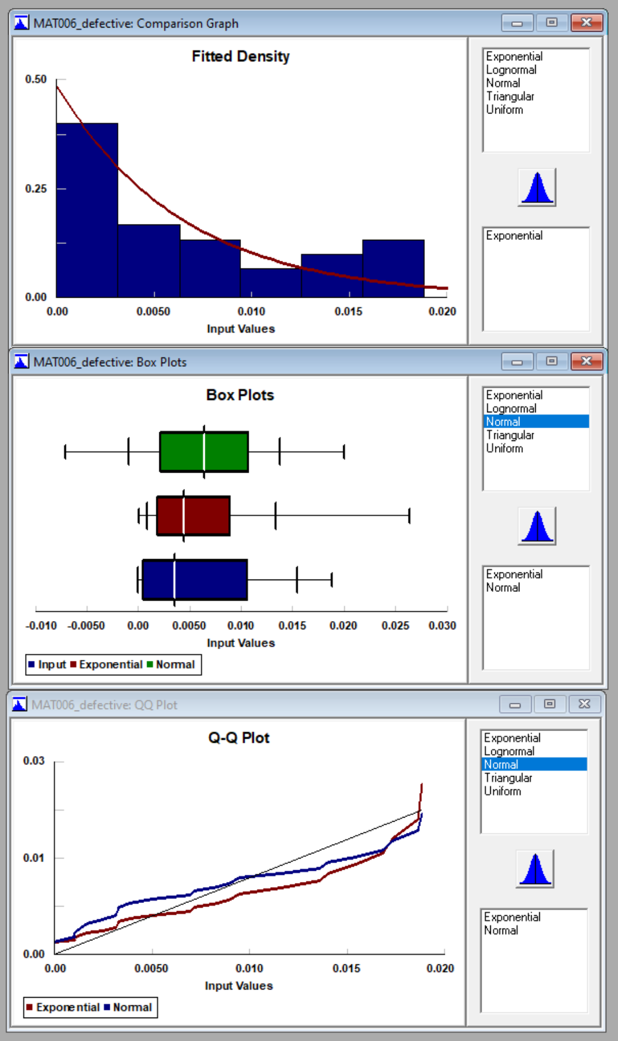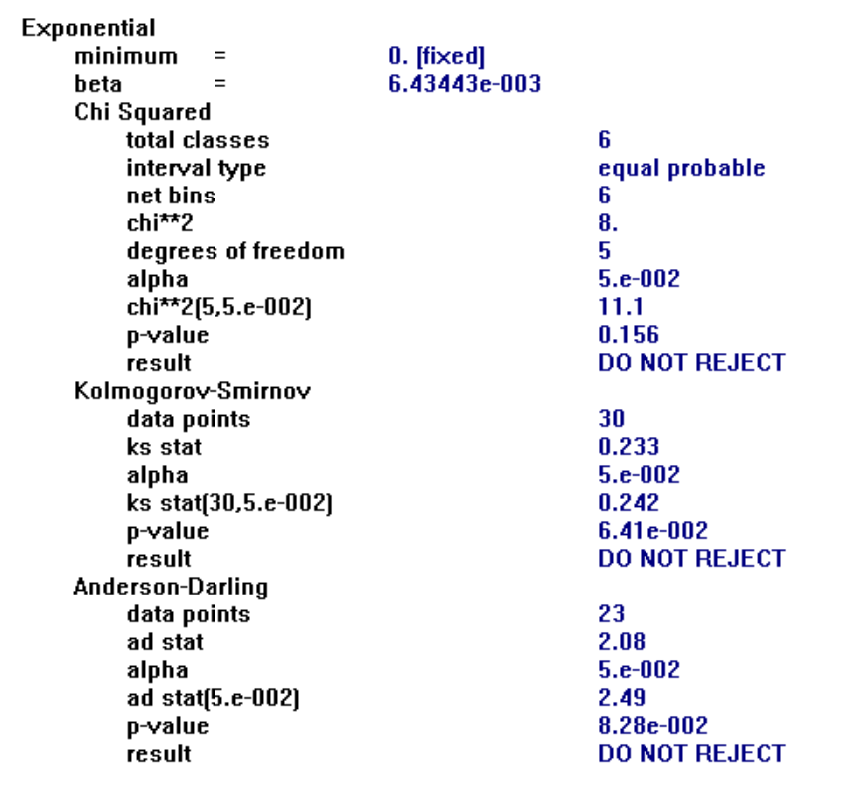

# MAT007_PercentDefective

* Uniform Distribution

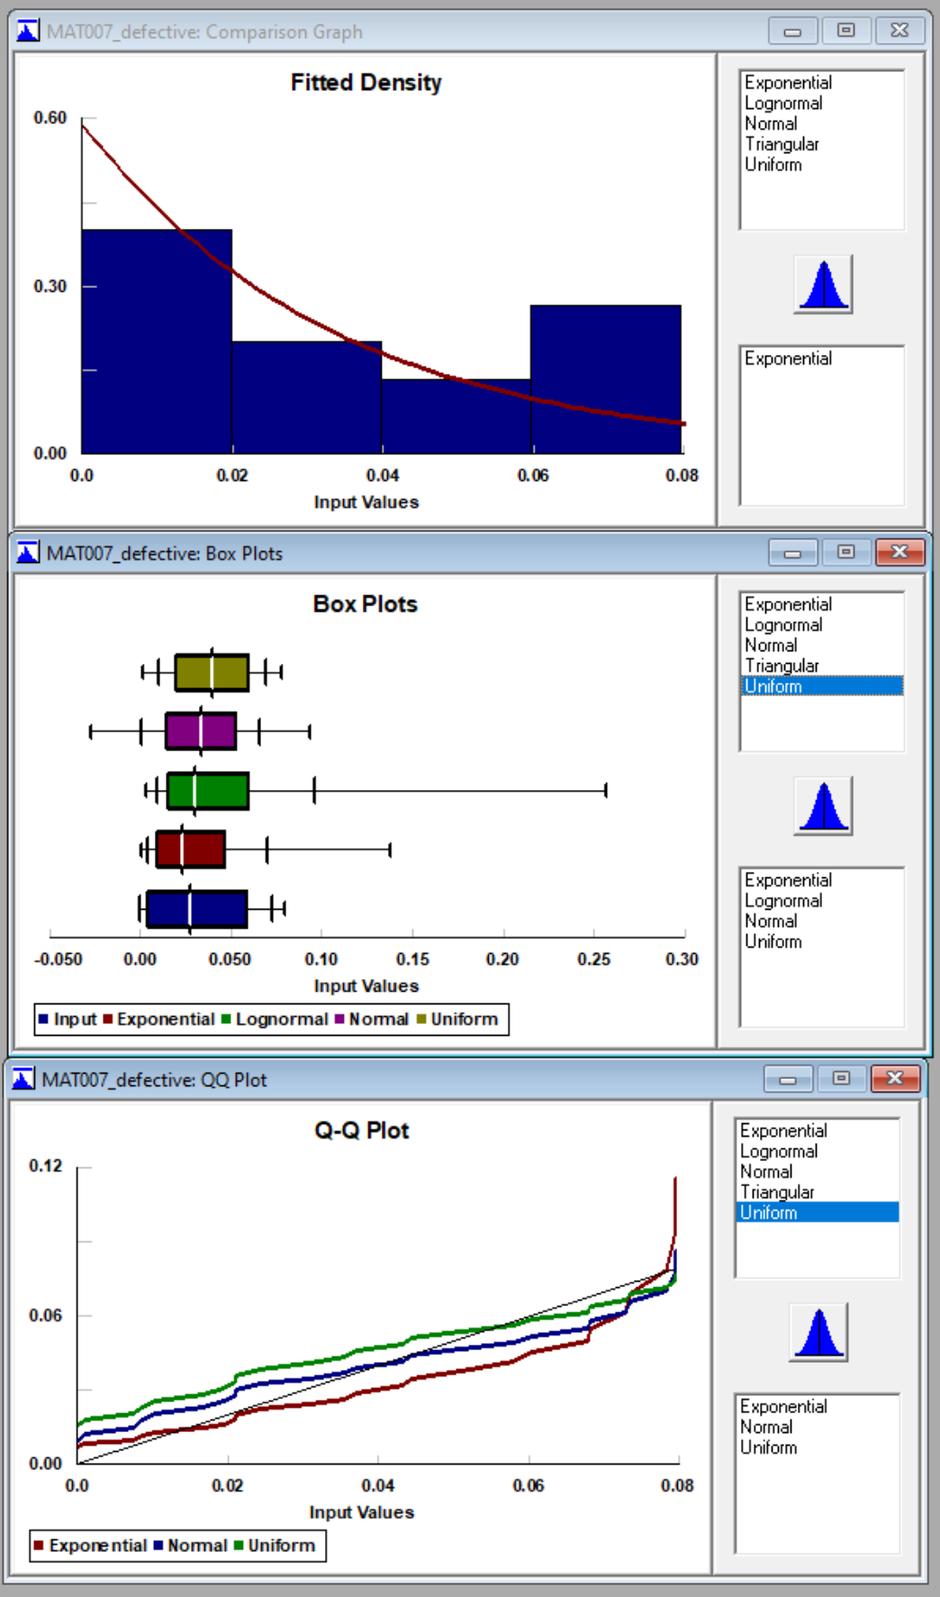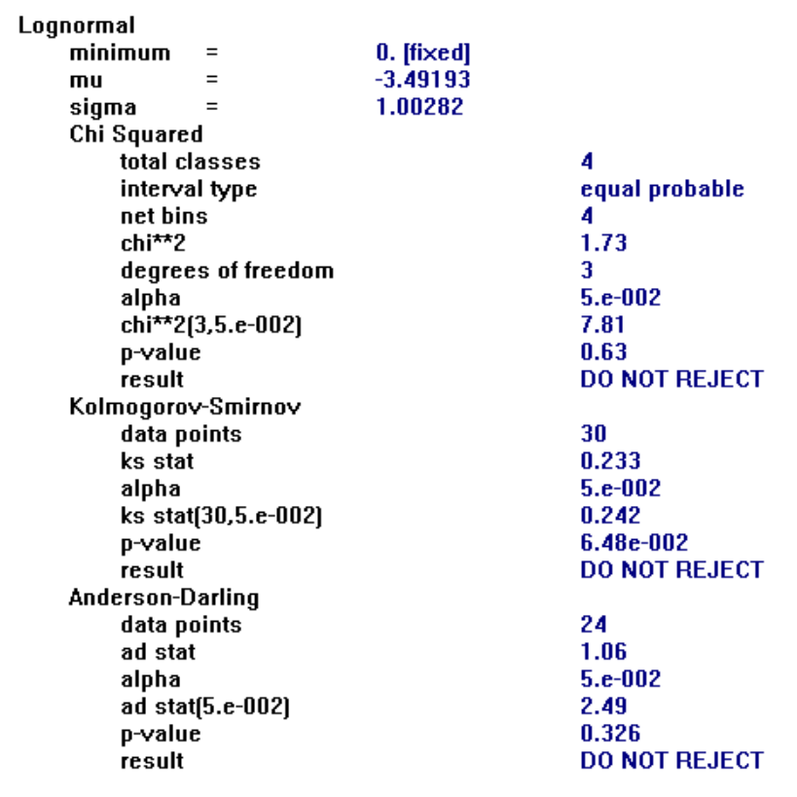

## 7.3 Supplier Lead Time Distribution Fitting

# BuildingCenter_LeadTime

* Binomial Distribution

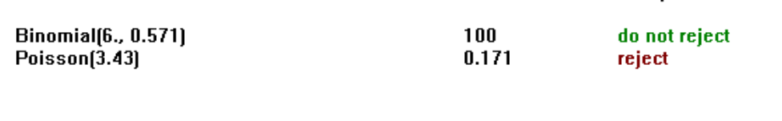

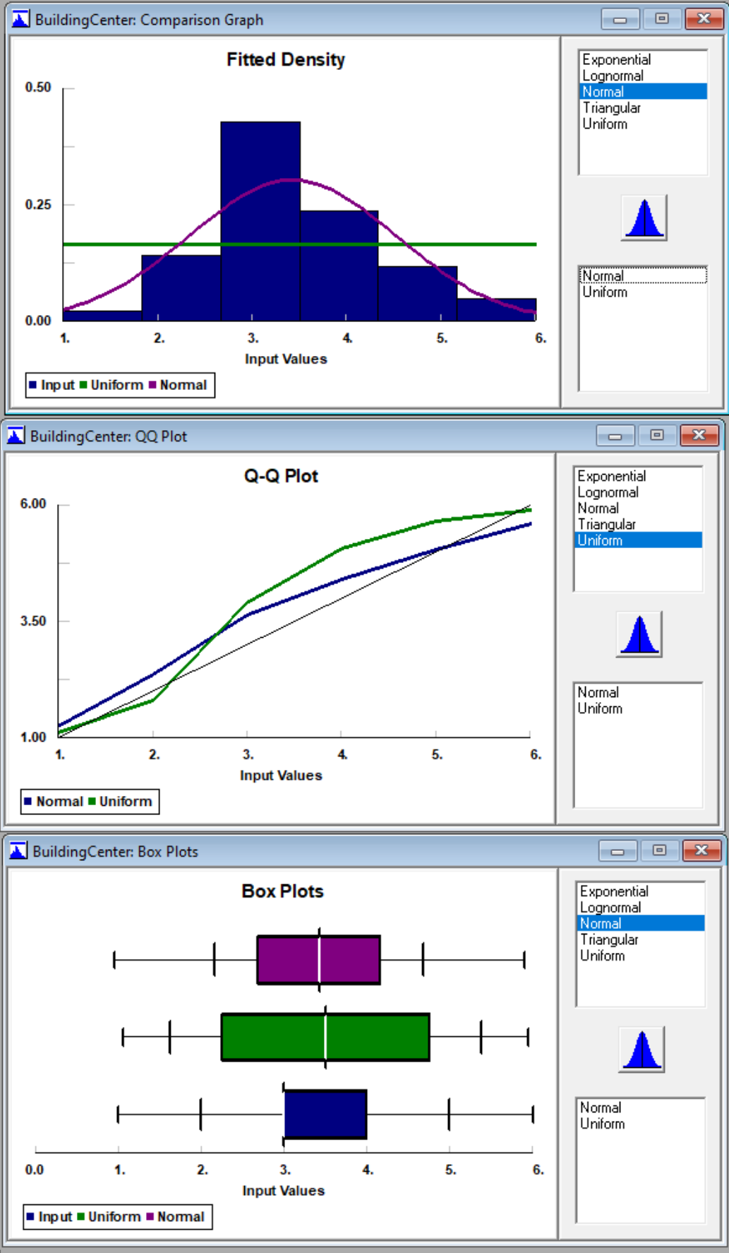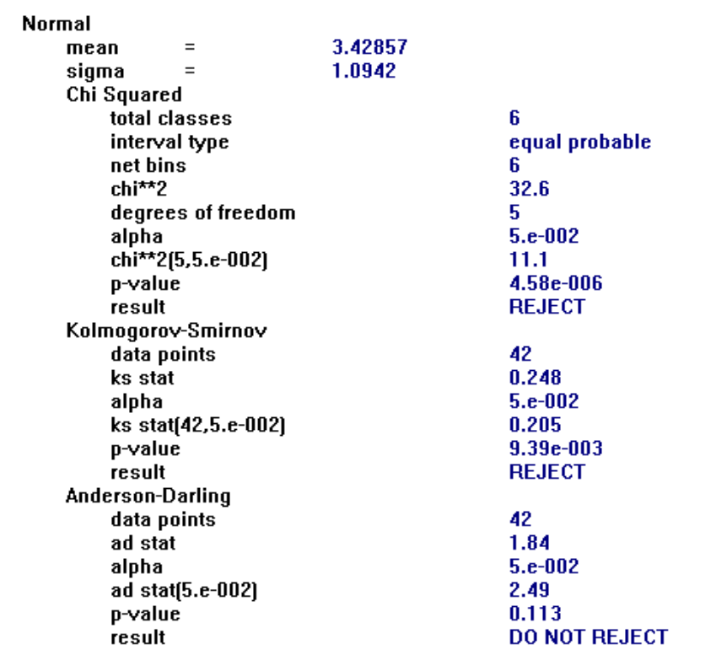

ClubHardware_LeadTime

* Poisson Distribution (Discrete)

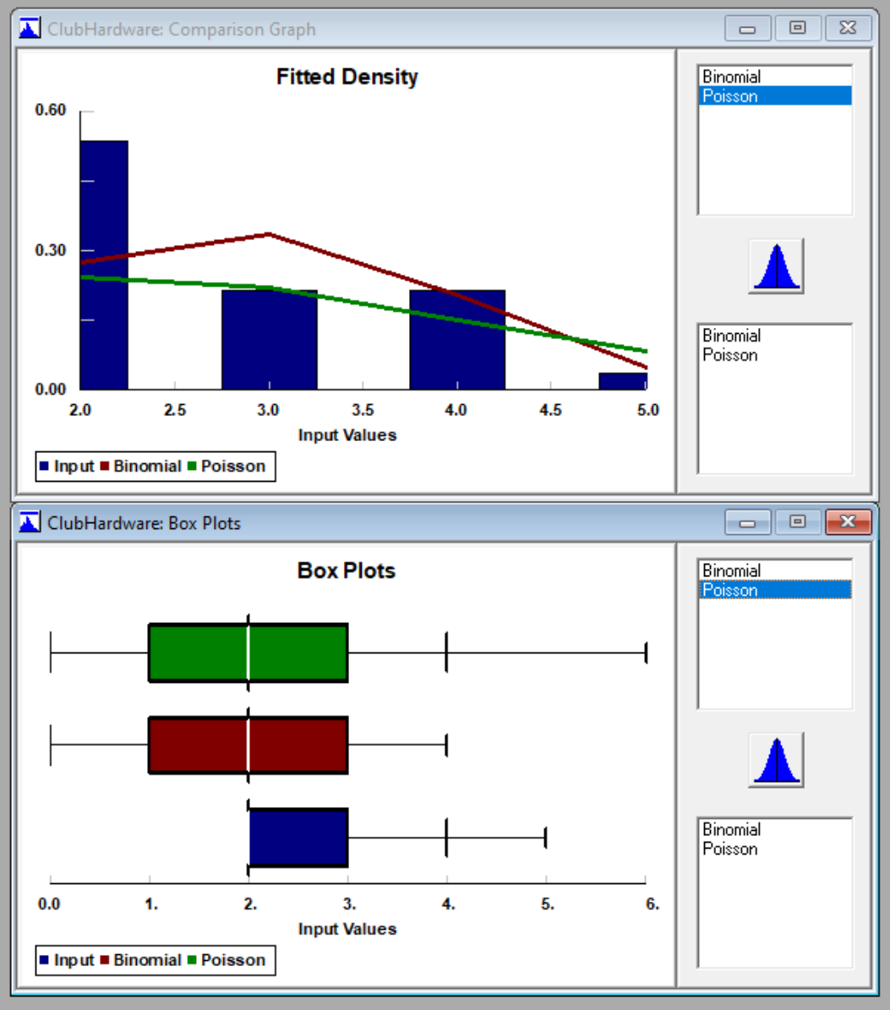

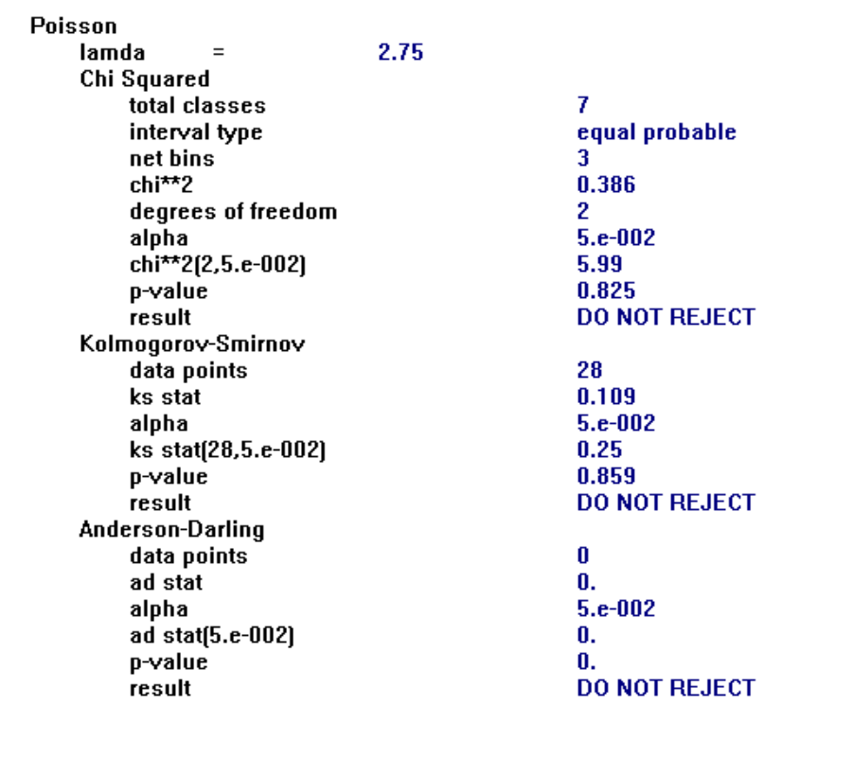

# KingsSupplyCompany_LeadTime

* Poisson Distribution

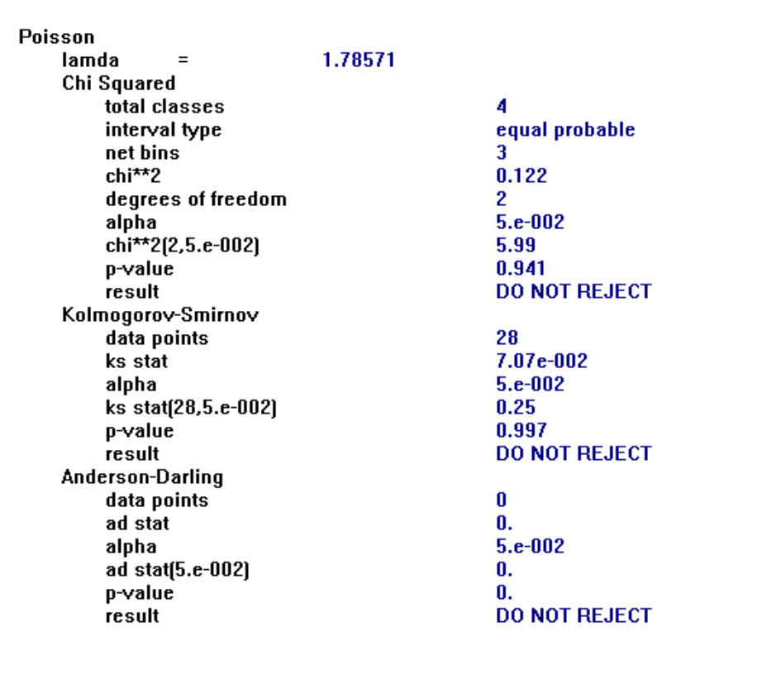

# HighesLumber_LeadTime

* Binomial Distribution

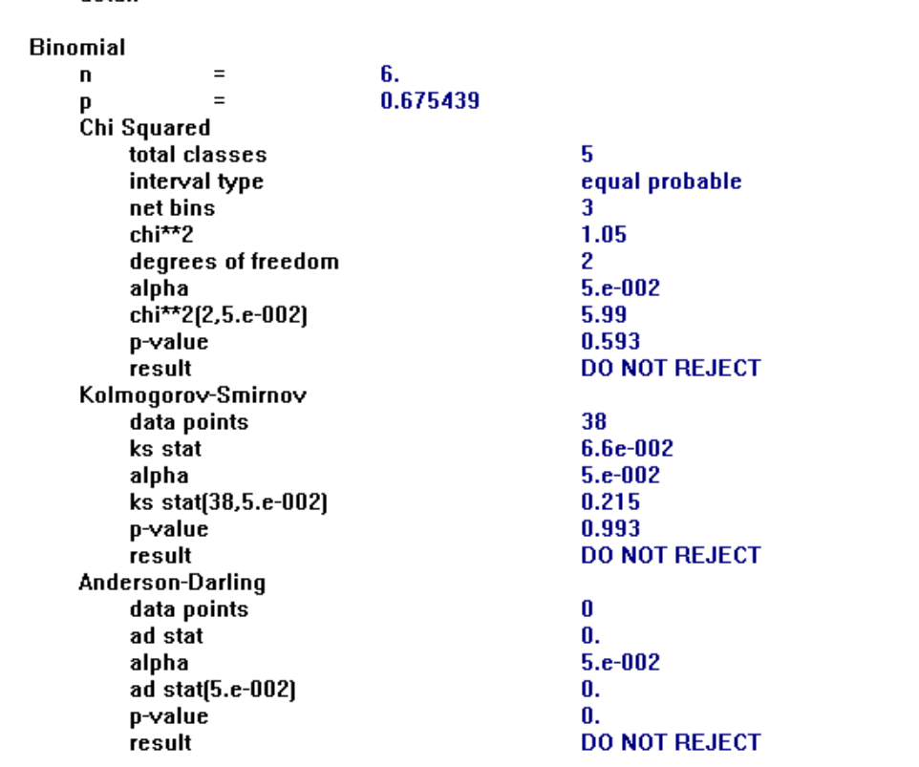

# JonesPaintStore_LeadTime

* Not enough data to determine, will leave with zero lead time since 50% of the values represent this

# LocalStorageHardware_LeadTime

* Poisson Distribution (Limited Data Points)

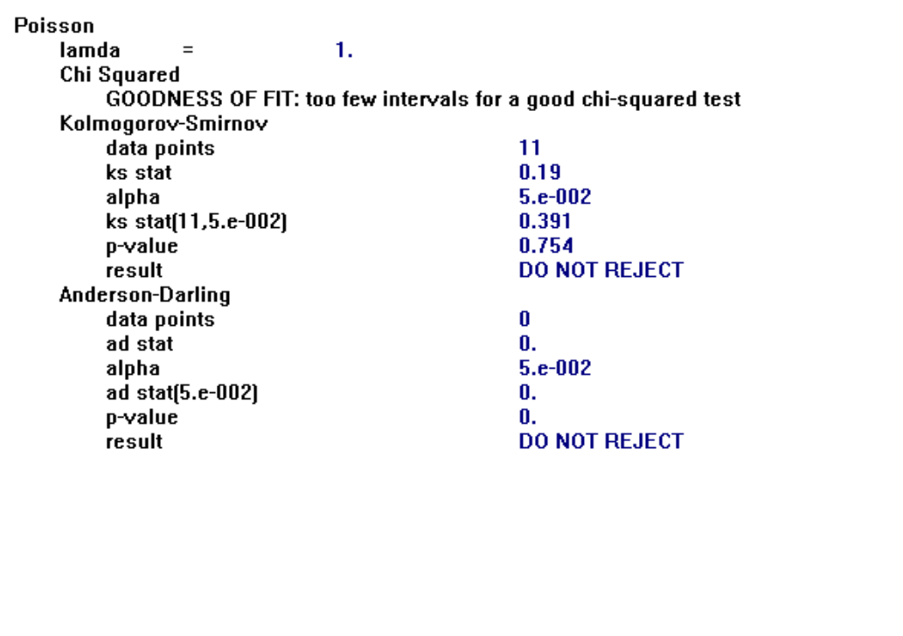

## 7.4 Station Processing Time Distribution Fitting

# Shelf Assembly Stations

## SA_Assemble

Triangular Distribution was the best fit given the data

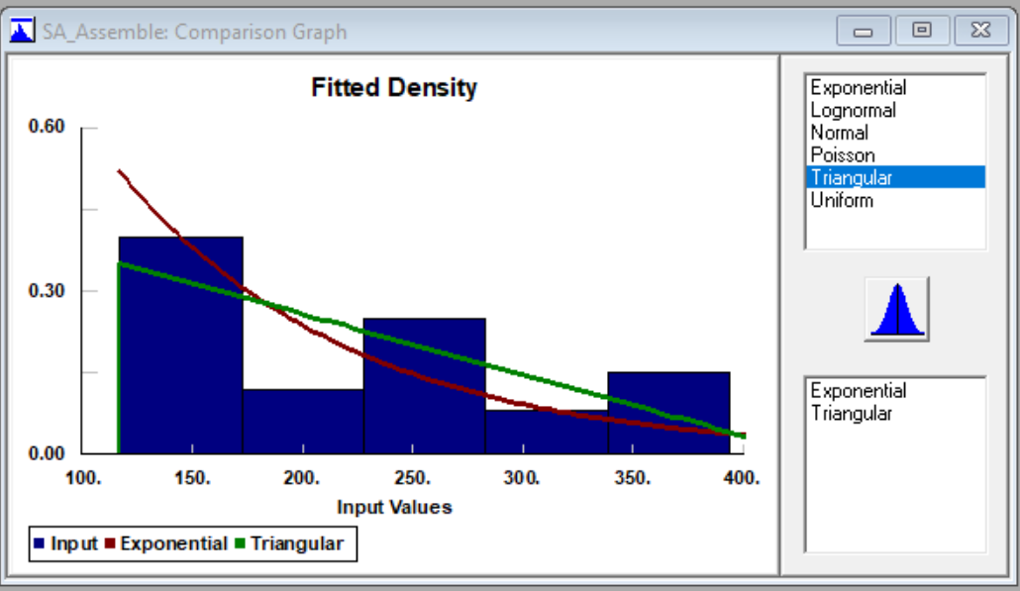

## **SA_Cut**

Triangular Distribution

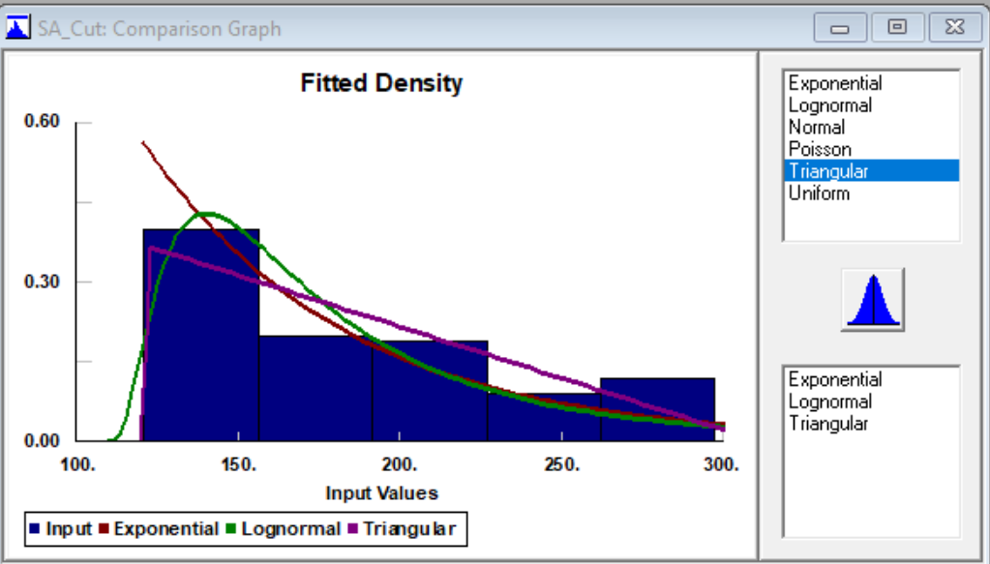

## **SA_Drill**

Triangular Distribution

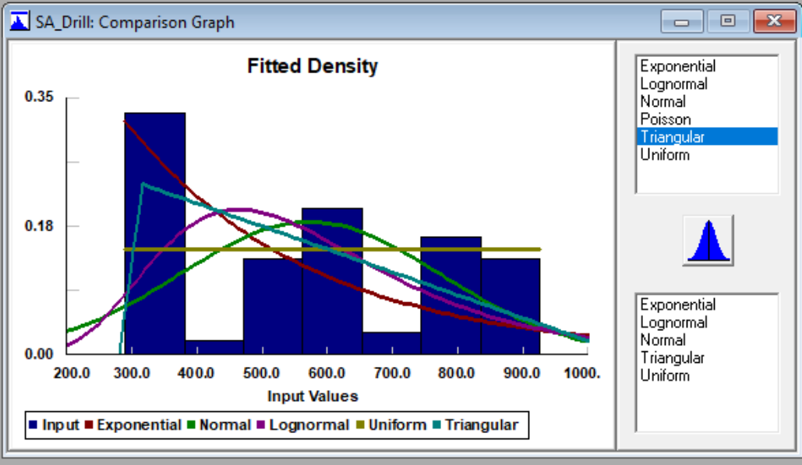

## **SA_Routing**

* Triangular Distribution

# Frame Assembly

## **FA_Assemble**

* Normal distribution for this fit

## 

## **FA_Cut**

* Triangular Distribution used though Normal Distribution also fit the data well

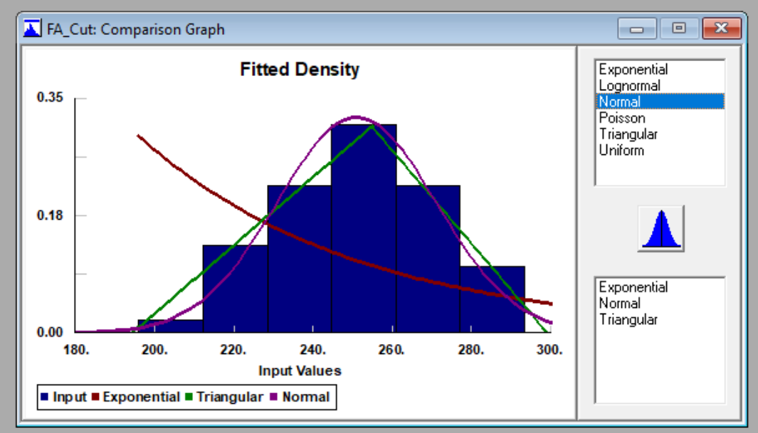

## **FA_Drill**

* Triangular Distribution

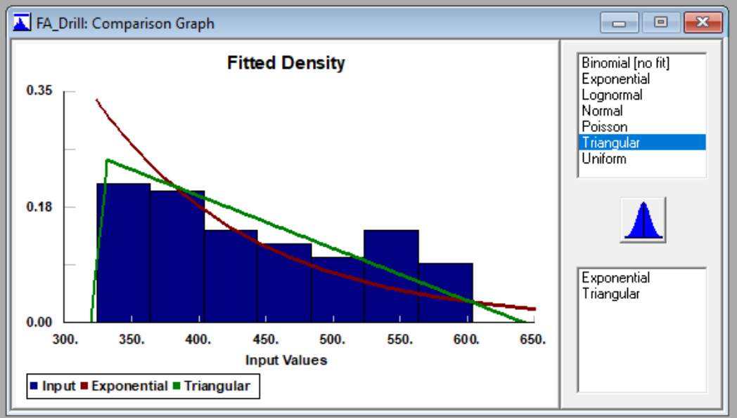

# Back Panel Assembly

## **Attach_BP**

* For this station a triangular offered the best fit capturing the sharp spike in values on the lower end of the distribution

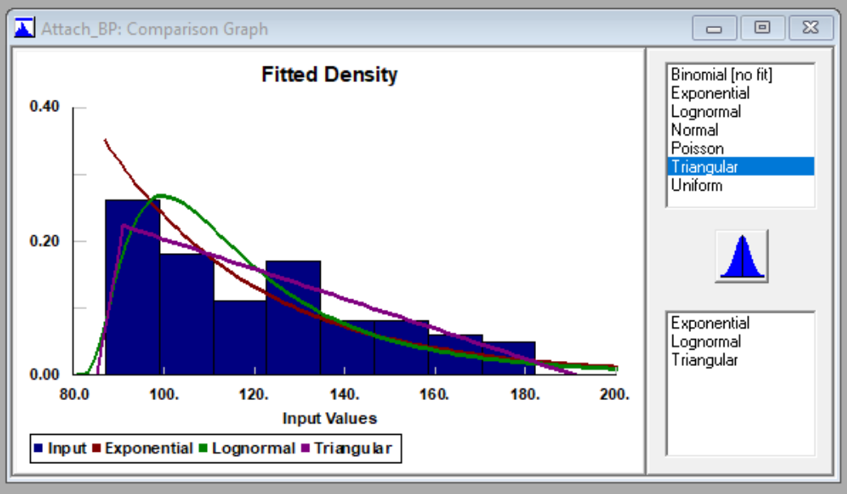

## **BP_Cut**

* Normal Distribution

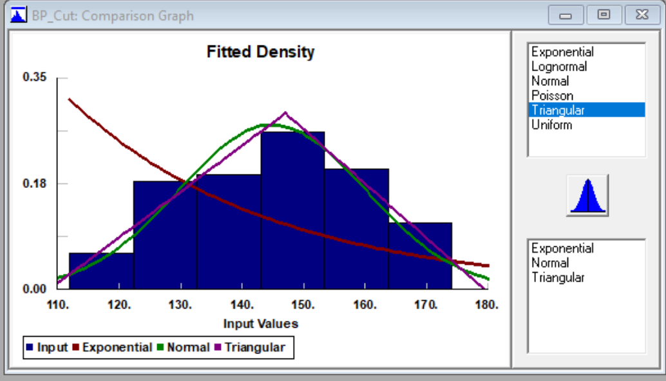

## **BP_Drill**

* Uniform Distribution

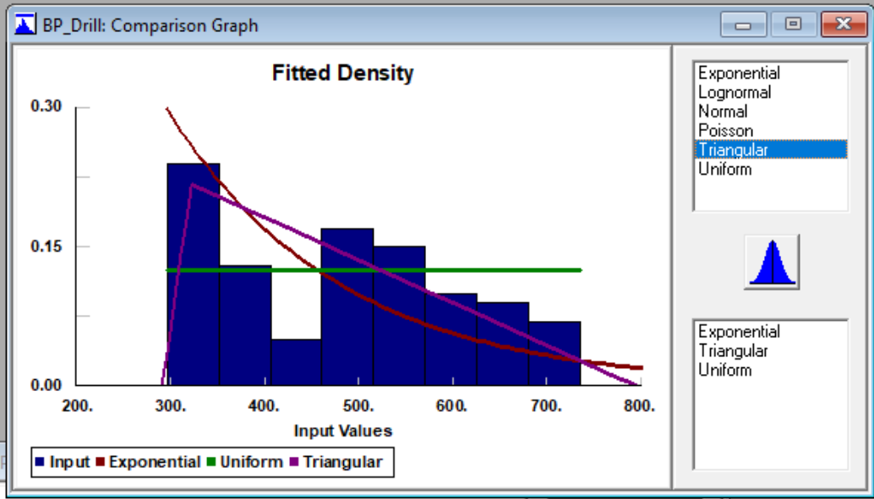

## **BP_Paint**

* Normal Distribution

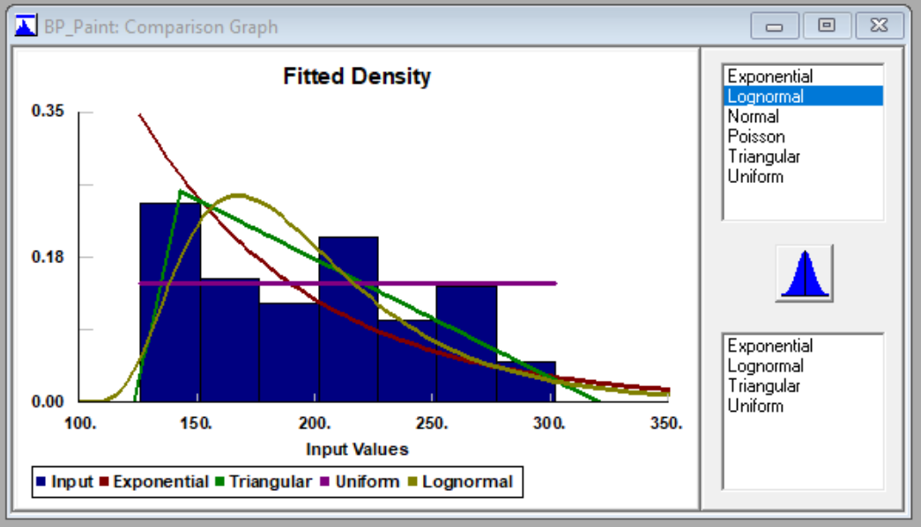

## **BP_Sand**

* Triangular Distribution

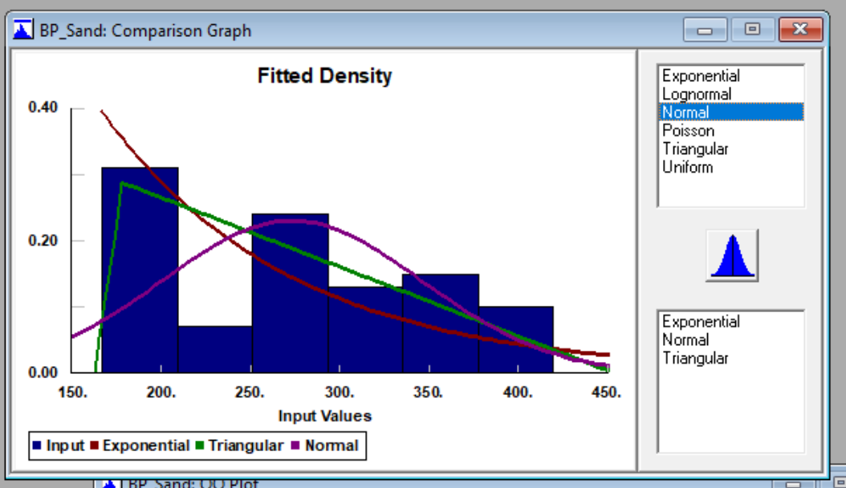

# Final Assembly

## **Assemble**

## For this station a triangular offered the best fit capturing the sharp spike in values on the lower end of the distribution

## 

## **Sand**

* For this station a triangular offered the best fit capturing the sharp spike in values on the lower end of the distribution

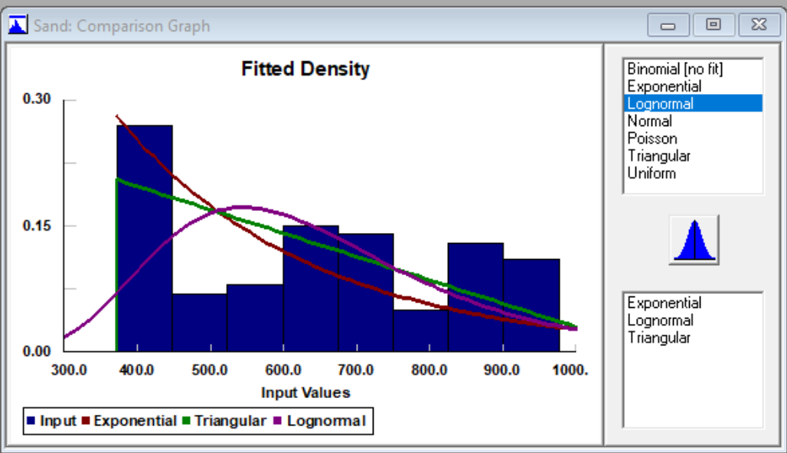

## **Paint**

* Triangular Distribution

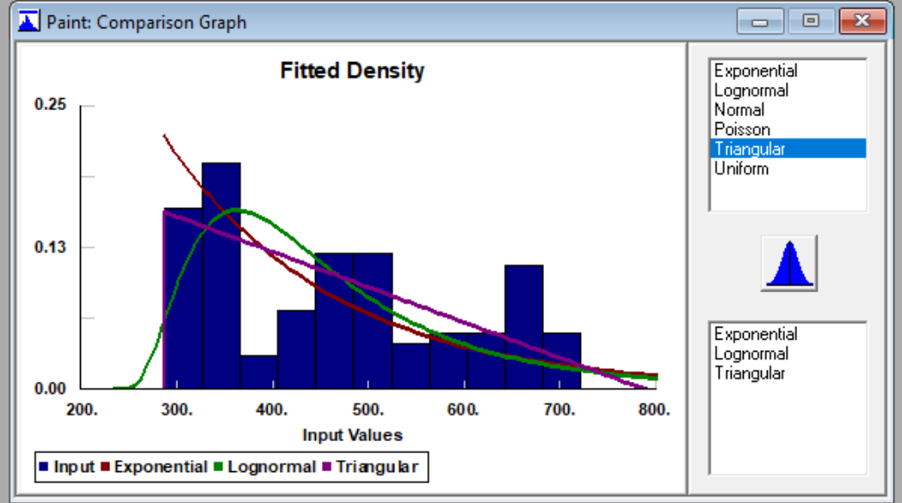

## 7.5 Material Inspection Time Distribution Fitting

# MAT001_InspectionTime

* Normal Distribution

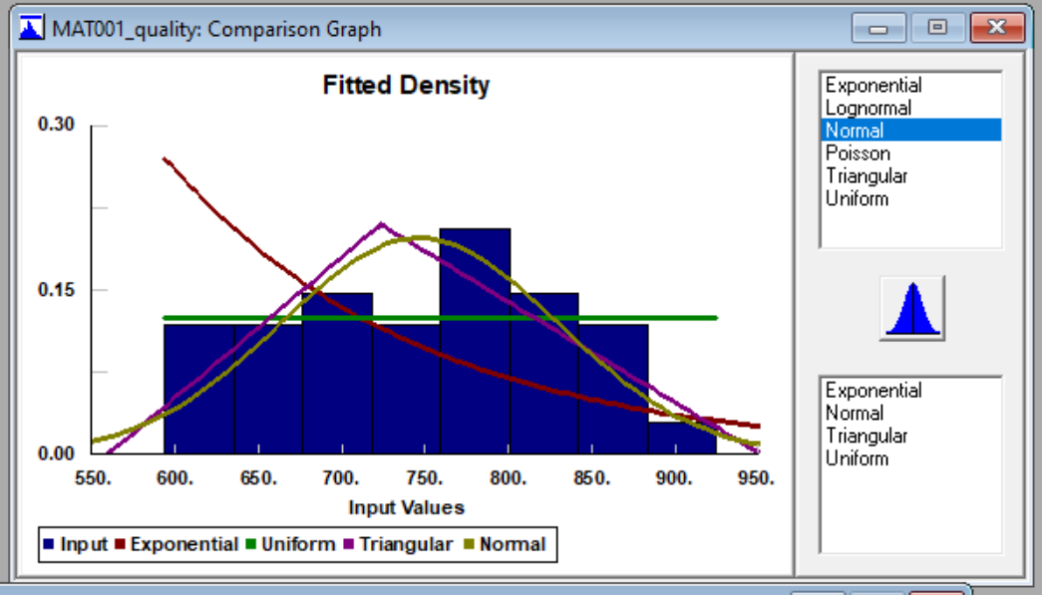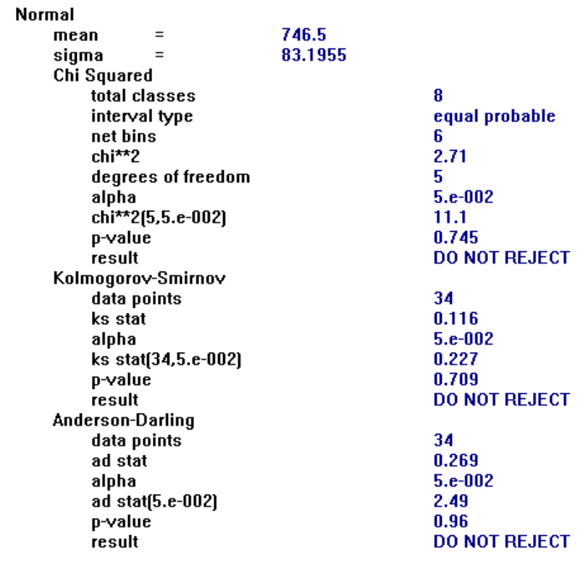

# MAT002_InspectionTime

* Triangular Distribution

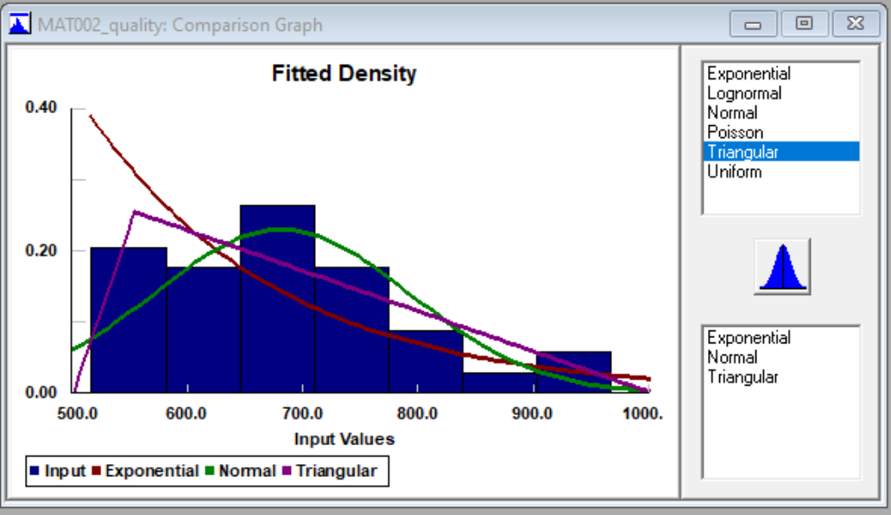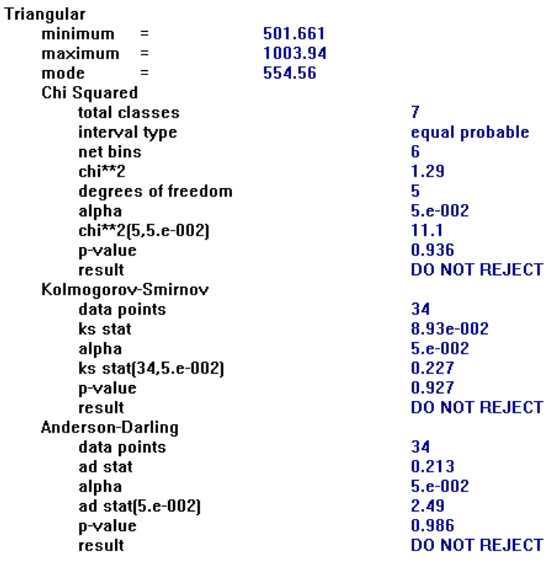

# MAT003_InspectionTime

* Triangular Distribution (Not enough data points to get an accurate estimation)

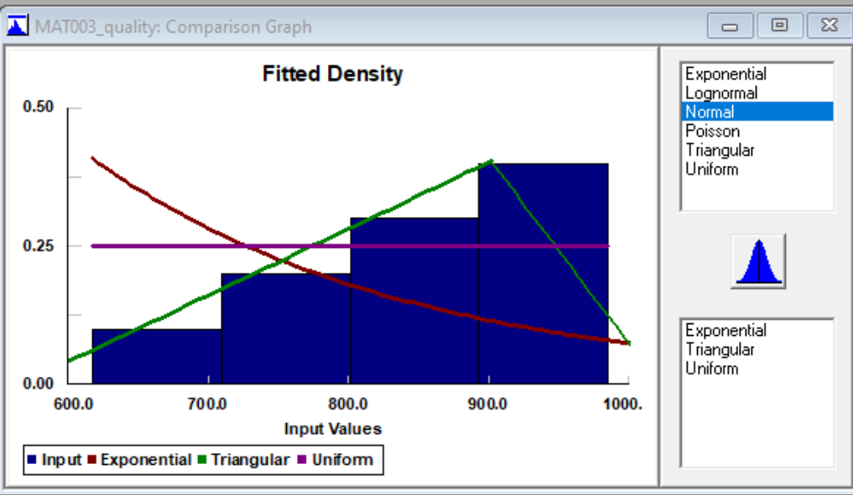

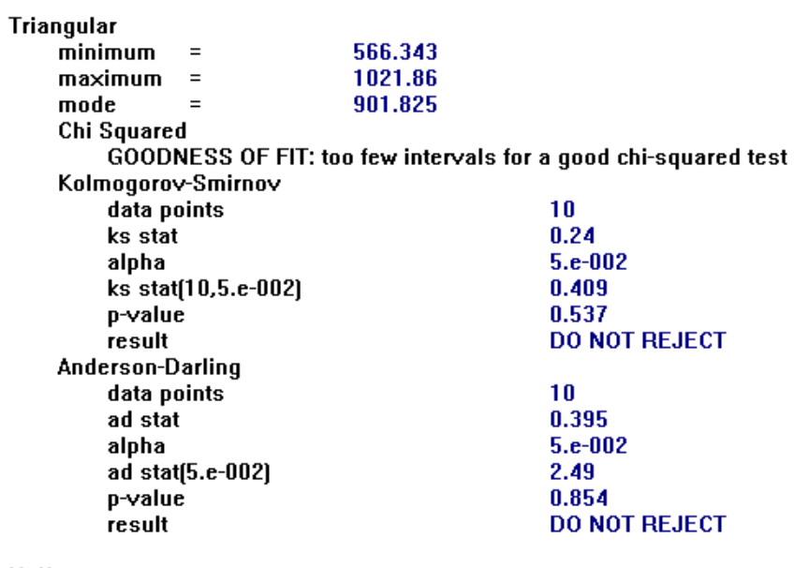

# MAT004_InspectionTime

* Uniform Distribution (Not enough data points)

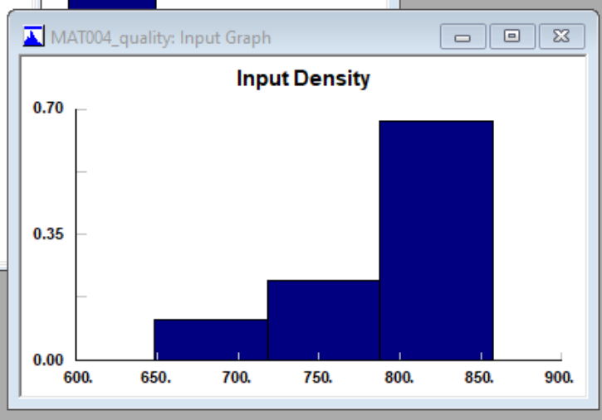

# MAT005_InspectionTime

* Lognormal Distribution

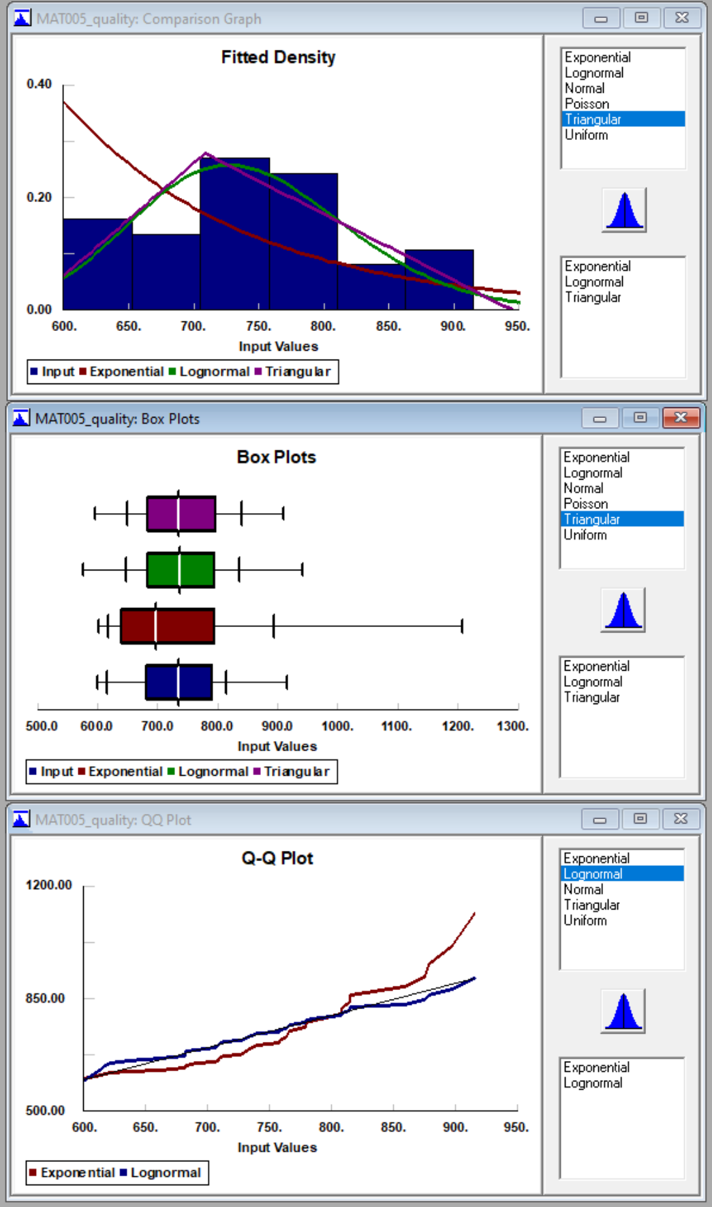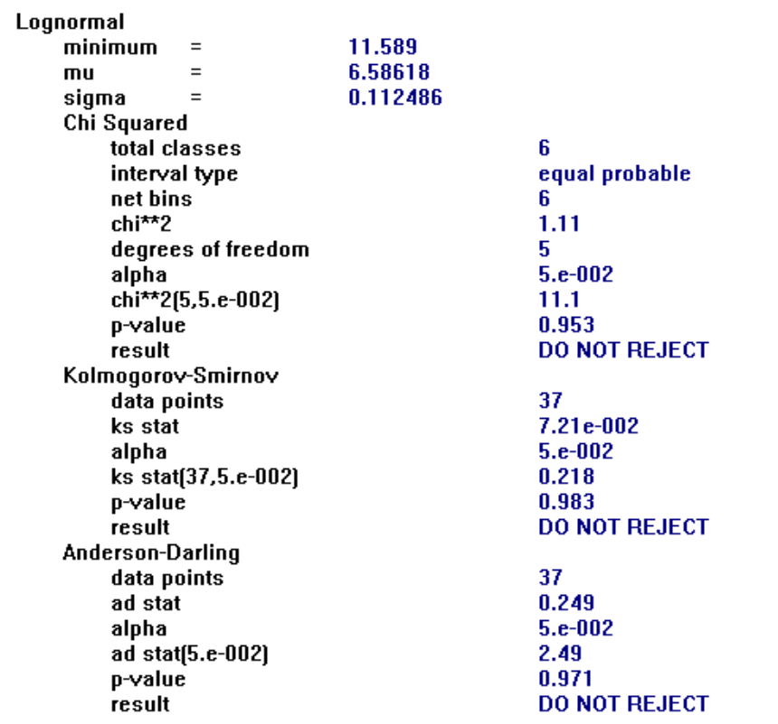

# MAT006_InspectionTime

* Uniform Distribution

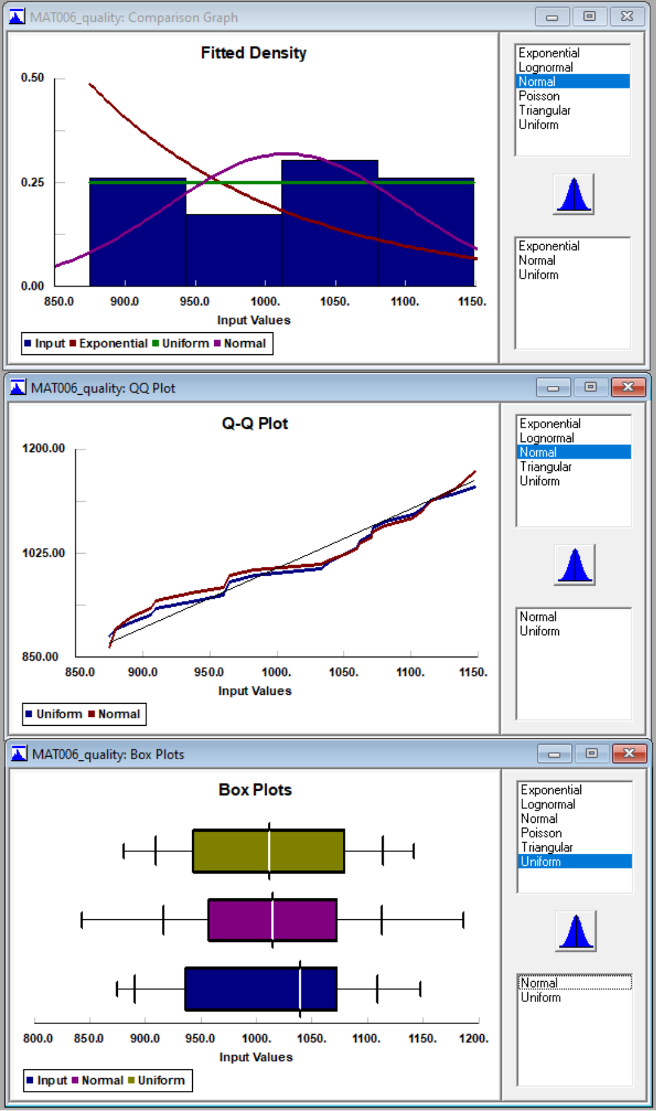

# MAT007_InspectionTime

* Normal Distribution

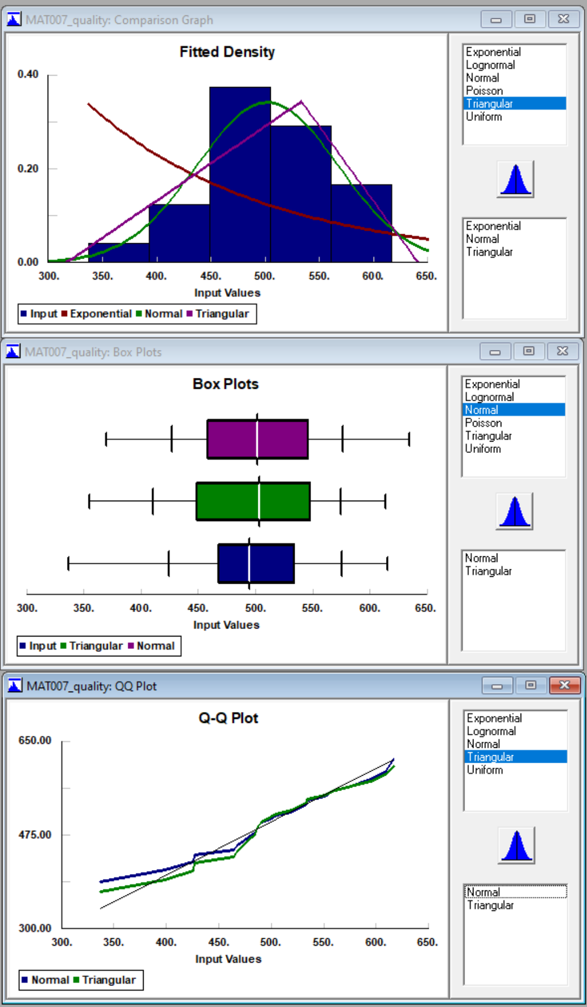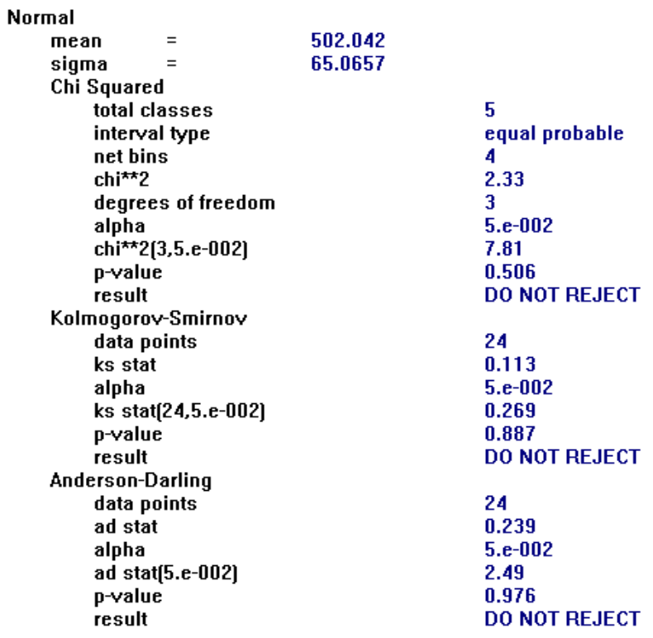

## 7.6 Distribution Fitting Result for all other Categories

## 

Distribution Fitting for Processing Times, Percent Defective, Inspections, and Deliveries

